# ACKNOWLEDGMENTS

First of all, I would like to pay my deepest gratitude to my **Parents** who always encourage, support and taking care of me for all the time. Especially, they give even more support and consider my busy time while I am writing this thesis.

I would like to express my gratitude and thanks to **Mr. PAN Sovanna**, head of Industrial and Mechanical Engineer Department, who has made his effort to lead the department and has looked after every student. Meanwhile, I also would like to thank all of my lectures for teaching me during academic years.

I wish to express my sincere thanks to **Dr. SRANG Sarot**, my advisor, who plays a crucial role during my research at dynamics and control laboratory. I am extremely thankful and indebted to him for sharing expertise, and sincere and valuable guidance and encouragement extended to me. He is open-minded who always love to exchange ideas with students.

Finally, I would like to thank my **Seniors** and **Colleagues** in Dynamics and Control Laboratory who always support and help in many other problems.

# អត្ថបទសង្ខេប

Simultaneous Localization and Mapping (SLAM) គឺជារបៀបមួយដែលត្រូវបានប្រើប្រាស់យ៉ាងទូលំទូលាយសម្រាប់ការកំណត់ទីតាំងរបស់រូប៉ូតនិងបង្កើតជាផែនទីនៅក្នុង

បរិស្ថានជំវិញដូចជាលំនៅដ្ធាន អាគារ សាលារៀន រោងចក្រ ជាដើម។ បើទោះបីជារបៀបមួយនេះត្រូវបានប្រើប្រាស់និងអភិវឌ្ឈន៍យ៉ាងក៏ដោយក៏ទិន័យដែលទទួលបានមានភាពល្អៀងដោយសារតែភាពមិនសុក្រិត (Noise) នៃឧបករណ៍និងបរិស្ថាន។ ដូចនេះហើយទើបឧបករណ៍ (Sensor) ផ្សេងៗត្រូវបានជ្រើសរើសមកប្រើប្រាស់បញ្ចូលគ្នា​​ (Fusion) ​ដើម្បីធ្វើអោយទិន័យដែលទទួលបានមានភាពប្រសើរដែលអាចទទួលយកបាន។ទិន័យដែលទទួលបានអាចអនុញ្ញាតឱ្យយើងប្រើប្រាស់និងអនុវត្តជាមួយប្រាជ្ញាសិប្បនិម្មិត (AI) ដូចជា ការគ្រង់នៃគន្លងដំណើរ (Path Planning), ការធ្វើដំណើរក្នុងបរិស្ថានដែលមានភាពមិនឋិតថេរ (Dynamic Environment Navigation), ការចតយានយន្តស្វ័យប្រវិត្ត(Autonomous Parking), ល។ សារណាមួយនេះនិយាយអំពីការអនុវត្ត Simultaneous Localization and Mapping (SLAM) ដោយប្រើប្រាស់ Light Detection and Ranging Sensor (Lidar)។ MATLAB, Robotic Operation System (ROS), GAZEBO Simulation ត្រូវបានប្រើសំរាប់ធ្វើគំរូ និង​ Simulate។

# RESUME

Simultanés Localisation et Mapping (SLAM) est une méthode qui a été utilisé par tout le monde pour localiser la location de robot et en même temp créer the plan de l’environnement au round de robot comme la maison, le bâtiment, l’université ou l’usine. Malgré le fait que cette méthode a été utilisé est développé de temp a temp, le data qui est obtient par cette méthode n’est pas précis cause par bruit d’appareil de senseur et l’environnement. De cette manière de plus en plus appareils de senseur sont choisi pour faire la fusion de senseur à la suite d’obtenir le data qui est optimise et plus acceptable. Le data qui nous obtenons par le SLAM méthode permet-nous d’utiliser and exécuter l’artificiel intelligent comme Trajectoires Planification (Path Planning), Navigation de Dynamique Environnement (Dynamic Environment Navigation), Autonome Parking (Autonomous Parking), etc. Ce mémoire présente l’application de Simultanés Localisation et Mapping (SLAM) par utilise Light Detection and Ranging Senseur (Lidar). MATLAB, Robotic Operation System (ROS), GAZEBO Simulation sont utilisé pour modéliser et simuler.

# ABSTRACT

Simultaneous Localization and Mapping (SLAM) is a method that widely used for localizing the location of the robot and at the same time, create Occupancy Map of the environment such as residence, building, university/school, and factory. Despite the fact that this method is used and developed from time to time, the data acquired is not accurate that cause by noise produced by sensor and the environment surrounding. Thus, multiple sensors were chosen for sensor fusion in pursuit of obtaining the synthesized data that is optimized and acceptable. The data acquired from SLAM method allow us to use and implement the Artificial intelligent (AI) such as Robot Path Planning, Dynamic Environment Navigation, Autonomous Parking, etc. This thesis presents the Implementation of Simultaneous Localization and Mapping (SLAM) using Light Detection and Ranging Sensor (LIDAR). MATLAB, Robotic Operation System (ROS), Gazebo Simulation is used for modeling and simulation.

# ABBREVIATION AND SYMBOLS

|  |  |
| --- | --- |
| **SLAM** | Simultaneous Localization and Mapping |
| **IMU** | Inertial Measurement Unit |
| **ROS** | Robotic Operation System |
| **WMR** | Wheeled Mobile Robot |
| **ICR** | Instantaneous center of rotation |
|  |  |
|  |  |
|  |  |
|  |  |

# TABLE OF CONTENTS

ACKNOWLEDGMENTS i

**អត្ថបទសង្ខេប** ii

RESUME iii

ABSTRACT iv

ABBREVIATION AND SYMBOLS v

TABLE OF CONTENTS vi

LIST OF FIGURES viii

LIST OF TABLES x

1. INTRODUCTION 1

1.1. Background 1

1.2. Objectives 1

1.3. Scope 1

2. LITERATURE REVIEWS 2

3. SIMULTANEOUS LOCALIZATION AND MAPPING USING LIDAR 3

3.1. Occupancy Grid 3

3.1.1. Introduction / Properties 3

3.1.2. Occupancy Grid Mapping Algorithm 4

3.1.3. Inverse Sensor Model for Lidar 8

3.2. Simultaneous Localization and Mapping (SLAM) Algorithm 9

3.3. Robotic Operating System (ROS) 10

3.3.1. Gazebo Simulation 11

3.3.1.1 Gazebo Environment 11

3.3.1.2 Subscribed / Published Topic 12

3.3.2. Coordinate Frame 13

3.3.3. tf Tree 14

3.3.4. RVIZ 15

3.4. SLAM Packages 15

3.4.1. Hector SLAM Package (ROS) 15

3.4.2. Gmapping SLAM Package (ROS) 18

3.4.3. MATLAB SLAM Package 20

3.5. Wheel Mobile Robot 21

3.5.1. Differential Drive WMR Kinematic Model 23

3.6. Sensor 26

3.6.1. Light Detection and Ranging Sensor (LIDAR) 26

3.6.1.1 Coordinate Frame 27

3.6.1.2 Published ROS Topic 28

3.6.2. Odometry 28

3.6.2.1 Published ROS Topic 28

4. SIMULATION AND DISCUSSION 30

4.1. Simulation 30

4.2. Preparation Simulation 30

4.3. Data Collection and Analysis 31

5. CONCLUSION AND RECOMMENDATION 43

5.1. Conclusion 43

5.2. Recommendation Future Work 43

REFERENCE 44

APPENDIX A 45

APPENDIX B 47

APPENDIX C 50

# LIST OF FIGURES

**Figure 3.1.** Occupancy Grid Map 3

**Figure 3.2.** Occupancy Grid Map Cell 4

**Figure 3.3.** Occupancy Grid Map Probability Cell 5

**Figure 3.4**. ROS Framework 10

**Figure 3.5.** Gazebo Simulation Window 11

**Figure 3.6.** Turtlebot3 Burger Simulation Window 11

**Figure 3.7.** Gazebo Simulation ROS Topic 12

**Figure 3.8.** Coordinate Frame Relationship (a) Multiple Map; (b) Single Map 13

**Figure 3.9.** Simulation Coordinate Frame 14

**Figure 3.10.** RVIZ Window 15

**Figure 3.11.** Hector SLAM tf frame 17

**Figure 3.12.** Gmapping SLAM tf frame 20

**Figure 3.13.** Turtlebot3 Burger 21

**Figure 3.14.** Turtlebot3 Burger Specification 22

**Figure 3.15.** 2D Coordinate of Robot 23

**Figure 3.16.** Differential Drive Kinematics 24

**Figure 3.17.** Lidar 26

**Figure 3.18.** Lidar Coordinate System 27

**Figure 3.19.** Lidar Laser Beam 27

**Figure 4.1.** Simulation Flow 30

**Figure 4.2.** MATLAB Pose Graph SLAM gazebo_stage_1 31

**Figure 4.3.** MATLAB Occupancy Map gazebo_stage_1 31

**Figure 4.4.** MATLAB Pose Graph SLAM gazebo_stage_2 32

**Figure 4.5.** MATLAB Occupancy Map gazebo_stage_2 32

**Figure 4.6.** MATLAB Pose Graph SLAM gazebo_stage_3 33

**Figure 4.7** MATLAB Occupancy Map gazebo_stage_3 33

**Figure 4.8.** MATLAB Pose Graph SLAM gazebo_world 34

**Figure 4.9.** MATLAB Occupancy Map gazebo_world 34

**Figure 4.10.** MATLAB Pose Graph SLAM gazebo_house 35

**Figure 4.11.** MATLAB Occupancy Map gazebo_house 35

**Figure 4.12.** Gmapping SLAM Occupancy Map gazebo_stage_1 36

**Figure 4.13.** Gmapping SLAM Occupancy Map gazebo_stage_2 36

**Figure 4.14.** Gmapping SLAM Occupancy Map gazebo_stage_3 37

**Figure 4.15.** Gmapping SLAM Occupancy Map gazebo_world 37

**Figure 4.16.** Gmapping SLAM Occupancy Map gazebo_house 38

**Figure 4.17.** Hector SLAM Occupancy Map gazebo_stage_1 38

**Figure 4.18.** Hector SLAM Occupancy Map gazebo_stage_2 39

**Figure 4.19.** Hector SLAM Occupancy Map gazebo_stage_3 39

**Figure 4.20.** Hector SLAM Occupancy Map gazebo_world 40

**Figure 4.21.** Hector SLAM Occupancy Map gazebo_house 40

**Figure 4.22.** Gmapping SLAM tf Tree 41

**Figure 4.23.** Hector SLAM tf Tree 42

# LIST OF TABLES

**Table 3.1.** The Occupancy Grid Algorithm, with Binary Bayes Filter (Thrun, 2002) 7

**Table 3.2.** Inverse 2D Lidar Sensor Model Algorithm (Steven Waslander, n.d.) 8

**Table 3.3.** Publish and Subscribe Simulation Topic 12

**Table 3.4.** Publish and Subscribe Hector SLAM Topic 16

**Table 3.5.** Hector SLAM Parameters 16

**Table 3.6.** Publish and Subscribe Gmapping SLAM Topic 18

**Table 3.7.** Gmapping SLAM Parameters 18

**Table 3.8.** MATLAB SLAM Function 20

**Table 3.9.** Hardware Specification 22

**Table 3.10.** WMR Sensor 23

**Table 3.11.** Lidar Properties 28

**Table 3.12.** Odometry Properties 29

# INTRODUCTION

## Background

Simultaneous Localization and Mapping (SLAM) has been known to be one of the methods that has been used to localize the position of Robot in Global Frame at the same time creating the map out of that environment to further and enhance its autonomous functionality. To obtain the most accurate map data, multiple devices have been used in sensor fusion method to produce the best possible result. SLAM method has been widely used with Wheeled Mobile Robot (WMR) in order to acquire the map of the environment that the robot or vehicle currently in. The map of the environment that acquired from this method could be further in used of Path Planning and Autonomous Navigation.

## Objectives

In this project, we present SLAM algorithm to build Occupancy Grid Map of surrounding environment using Lidar by the implementation of Hector SLAM ROS package, Gmapping SLAM ROS package and MATLAB SLAM. Gazebo 3D Simulation Software will be used to simulate the model of WMR that equipped with simulate sensor (Lidar, IMU, Odometry) and the surrounding environment. RVIZ will be used as the visualization tool for Occupancy Map, WMR model, robot trajectories and sensor data.

## Scope

The Occupancy Grid Map is represented in two dimensional (2D) as . The Two Wheels Differential drive WMR is designed in two dimensional (2D) planar motion and the orientation of the robot is represented by the rotation angle from the global map frame. All the work has been done inside the Gazebo 3D Simulation. The environment is considered to be Indoor. We are using the sensor data that is obtained from the simulation 2D Lidar, IMU, Odometry.

# LITERATURE REVIEWS

Navigating of robots around the unknown environment has been a challenging problem for the robotic community for the past years. The majority of mobile robot require map of the environment so that it can move inside that place. Building the map from the bottom up is very essential because it reduces the amount of work that involves the installation of mobile robots. In addition, it enables the mobile robot to easily adapt to change without human intervention. As the matter of fact, mapping is one of the core competencies of a truly autonomous robot.(Thrun, 2002)

SLAM is a method that is used for building and updating the map of the environment while the robot is moving inside the unknown environment and localizing itself in the map. SLAM takes all the available sensors that are equipped on the robot to estimate its position and collects scans from any ranging sensor, builds up the occupancy map and determines the location of itself in that map. The trajectory of the mobile robot and landmark are all being estimated from the input data of the sensor online without pre-knowledge of location.

In SLAM, we use a probabilistic approach in order to solve the SLAM problem. We called it Probabilistic SLAM. In this approach the probabilistic distribution is required to be computed during the process. There are two main forms of the SLAM problem: Online SLAM and Full SLAM.

Online SLAM is the process of estimating the posterior map from a recently collected data from sensors at time

|  |  |  |
| --- | --- | --- |
|  |  | **(Eq 2.1.)** |

Where is the position at time

is the map

is the measurement

is the control vector

Full SLAM is the process of calculating the posterior map from the full trajectories of the mobile robot.

|  |  |  |
| --- | --- | --- |
|  |  | **(Eq 2.2.)** |

Where is the position from the initial time to time

is the map

is the measurement

is the control vector

# SIMULTANEOUS LOCALIZATION AND MAPPING USING LIDAR

## Occupancy Grid

### Introduction / Properties

Occupancy grid map is one of many pieces of information that are required for the mobile robot for navigation tasks such as path planning, driving a round, mapping the environment, and localizing. It is a 2D representation of the environment.

Occupancy grid map consists of many occupancy grid cells. Each of grid cells is represented as an occupied cell or a free cell according to the calculation of binary probability value. In short, a 2D occupancy map is a large set that contains a probability value in every cell.

|  |  |  |
| --- | --- | --- |
|  |  | **(Eq 3.1.)** |

The occupied cell is represented by a probability value of (1) with black color and the free cell is represented by a probability value of (0) with white color. On the Assumption of that the cell is either occupied or free, each probability value contain in each cell are independent, and the surrounding environment is static.

Occupancy grid maps are ﬁne-grained grids deﬁned over the continuous space of locations and often used after solving the SLAM problem by some other means, and taking the resulting path estimates for granted.

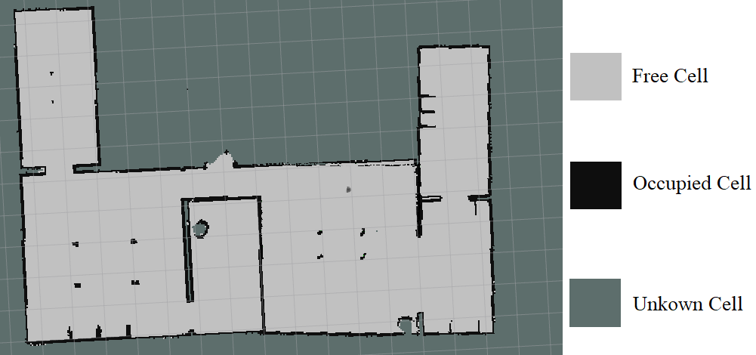

**Figure 3.1.** Occupancy Grid Map

### Occupancy Grid Mapping Algorithm

In Occupancy Grid Mapping Algorithm also known as mapping with known pose the control is omitted. The main goal of any occupancy grid mapping algorithm is to calculate the posterior over maps given the data represented in probability value

|  |  |  |
| --- | --- | --- |
|  |  | **(Eq 3.2.)** |

Where is the map

the set of all measurements up to time

is the path of the robot, that is, the sequence of all its poses.

In the occupancy grid, each grid cells address is represented with index. The size of grid cell is expressed with map resolution [m/cell].

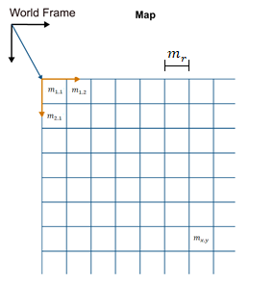

**Figure 3.2.** Occupancy Grid Map Cell

Let denote the grid cell with index . An occupancy grid map partitions the space into ﬁnitely many grid cells

|  |  |  |
| --- | --- | --- |
|  |  | **(Eq 3.3.)** |

The notation or will refer to a probability that a grid cell is occupied.

The standard occupancy grid approach breaks down the problem of estimating the map into a collection of separate problems, namely that of estimating

|  |  |  |
| --- | --- | --- |
|  |  | **(Eq 3.4.)** |

for all grid cell . Each of these estimation problems is now a binary problem with

static state.

 This decomposition is convenient but not without problems. In particular, it does enable us to represent dependencies among neighboring cells; instead, the posterior over maps is approximated as the product of its marginals:

|  |  |  |
| --- | --- | --- |
|  |  | **(Eq 3.5.)** |

As the estimation of Occupancy Grid cell has become a static state binary problem, we are using Static State Binary Bayes Filters.

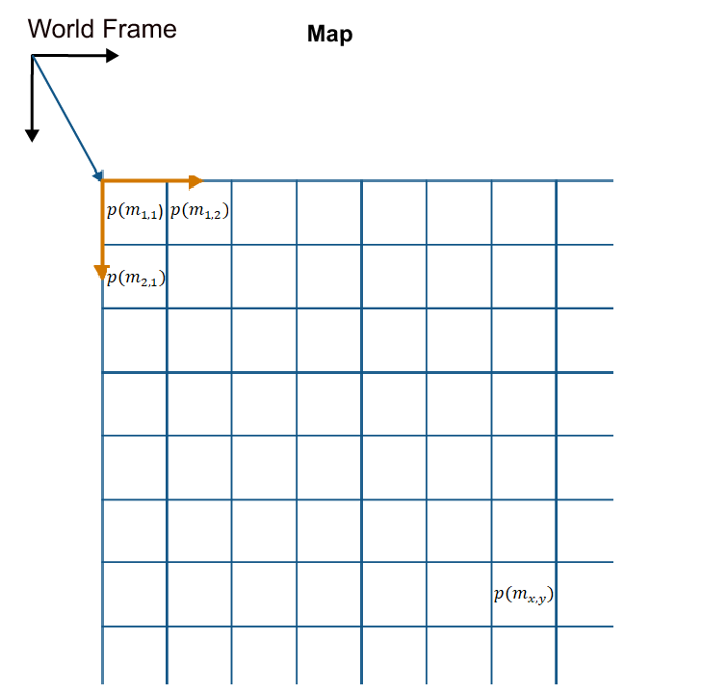

**Figure 3.3.** Occupancy Grid Map Probability Cell

When using occupancy grids with probability values, the goal is to estimate the probability of obstacle locations for use in real-time robotics applications. The Occupancy Map uses a *log-odds* representation of the probability values for each cell. Each probability value is converted to a corresponding *log-odds* value for internal storage. The value is converted back to probability when accessed. This representation efficiently updates probability values with the fewest operations. Thus, integrate sensor data into the map can be calculate quickly.

(The MathWorks, 2019)

*Log-odd* Notation

|  |  |
| --- | --- |
|  | **(Eq 3.6.)** |

The *Log-odd* is the logarithm of above equation

|  |  |  |
| --- | --- | --- |
|  |  | **(Eq 3.7.)** |
|  |  | **(Eq 3.8.)** |

Substitute in with , We get

|  |  |  |
| --- | --- | --- |
|  |  | **(Eq 3.9.)** |

On Using Bayes rule, we get

|  |  |  |
| --- | --- | --- |
|  |  | **(Eq 3.10.)** |

Using Markov Assumption on **Eq 3.10.**, we get

|  |  |  |
| --- | --- | --- |
|  |  | **(Eq 3.11.)** |

We have

|  |  |  |
| --- | --- | --- |
|  |  | **(Eq 3.12.)** |

Substitute **Eq 3.12.** to **Eq 3.11.**, we get

|  |  |  |
| --- | --- | --- |
|  |  | **(Eq 3.13.)** |

Using Markov Assumption on **Eq 3.13.**, We get

|  |  |  |
| --- | --- | --- |
|  |  | **(Eq 3.14.)** |

On We have

|  |  |  |
| --- | --- | --- |
|  |  | **(Eq 3.15.)** |

The same calculation above, we obtain

|  |  |  |
| --- | --- | --- |
|  |  | **(Eq 3.16.)** |

Divide **Eq 3.14.** with **Eq 3.16.**

|  |  |
| --- | --- |
|  | **(Eq 3.17.)** |

Apply on **Eq 3.17.**

We get

|  |  |  |  |  |
| --- | --- | --- | --- | --- |
|  | | | | **(Eq 3.18.)** |
|  |  | **(Eq 3.19.)** |
|  |  | **(Eq 3.20.)** |

Where

=

=

=

**Table 3.1.** The Occupancy Grid Algorithm, with Binary Bayes Filter (Thrun, 2002)

|  |  |
| --- | --- |
| Occupancy Grid Mapping Algorithm | Line |
| Algorithm occupancy_grid_mapping | 1 |
| For all cell do | 2 |
| If in perceptual field of then | 3 |
|  | 4 |
| else | 5 |
|  | 6 |
| endif | 7 |
| Endfor | 8 |
| return {} | 9 |

**Eq 3.20.** is used to update the occupancy grid cell. In **Table 3.1.**Line4, if the grid cell falls inside the scan area of lidar, the algorithm will return a new grid cell that its probability value change according to the scan if it is occupied or free. In **Table 3.1**.Line 6, if the grid cell does not fall inside the scan area of lidar, its probability value remains unchanged.

### Inverse Sensor Model for Lidar

In **Eq 3.20.**, to update the occupancy grid, we incorporate a new the measurement from the lidar and update the existing probability value inside each grid with new calculation from lidar. Given the current WMR position on a cell grid and the measurement from a lidar scan region, we assign the probability value to the cell that lidar beam past through. If the detection happens in cells grid, the probability value of that cells grid will be calculated with a new assign probability value from lidar output represented with , and the cells which shorter from occupied cell will be assign as free cells lidar output represented with . If there is not any occupied detection from lidar outside the lidar max scan range, the cells will be considered to be unknown represented with prior cells.

In this thesis, we assign 0.9

=0.4

0.5

**Table 3.2.** Inverse 2D Lidar Sensor Model Algorithm (Steven Waslander, n.d.)

|  |  |
| --- | --- |
| Inverse Lidar Sensor Model Algorithm | Line |
| Algorithm inverse_lidar_sensor_model | 1 |
| Let be the center of mass of | 2 |
|  | 3 |
|  | 4 |
|  | 5 |
| If | 6 |
| return | 7 |
| If | 8 |
| return | 9 |
| If | 10 |
| return | 11 |
| endif | 12 |

Where is the range from lidar to grid cell

is the center of cell

is sensor location

## Simultaneous Localization and Mapping (SLAM) Algorithm

There is numerous SLAM algorithm that has been develop over the year. One of them is Scan Matching. Scan matching is the process of aligning laser scans with each other (Scan to Scan Matching) or with an existing map (Scan to Map Matching). Using Scan Matching algorithm, the main idea is to find the rigid transformation in robot pose from two different scans. Scan Matching algorithm can be corporate with many different kinds of range finder sensors. Thus, in this thesis we use lidar as our range finder sensor. As the lidar scans data being subscribe with ROS and publish to the algorithm, scans get aligned with the existing map, or another scan and the matching is implicitly performed with all preceding scans.(Kohlbrecher et al., 2011)

To find the rigid transformation of robot pose that make the best lidar scan alignment, we have to find transformation that minimizes

|  |  |  |
| --- | --- | --- |
|  |  | **(Eq 3.21.)** |

Where

are the world coordinates of scan endpoint

is the function of , the pose of the robot in the world coordinate.

|  |  |  |
| --- | --- | --- |
|  |  | **(Eq 3.22.)** |

The function return the map value at the coordinate given by . Given some starting estimate of , we want to estimate which optimize the error measure according to

|  |  |  |
| --- | --- | --- |
|  |  | **(Eq 3.23.)** |

Using the first order of Taylor expansion of we get

|  |  |  |
| --- | --- | --- |
|  |  | **(Eq 3.24.)** |

This equation in minimized by setting the partial derivative with respect to to zero

|  |  |
| --- | --- |
|  | **(Eq 3.25.)** |

Solving for yields the Gauss-Newton equation for the minimization problem

|  |  |  |
| --- | --- | --- |
|  |  | **(Eq 3.26.)** |

Where

An approximation for the map gradient is provided is section IV-A in Hector SLAM (Kohlbrecher et al., 2011)

With **Eq 3.22.**, we get

|  |  |  |
| --- | --- | --- |
|  |  | **(Eq 3.27.)** |

## Robotic Operating System (ROS)

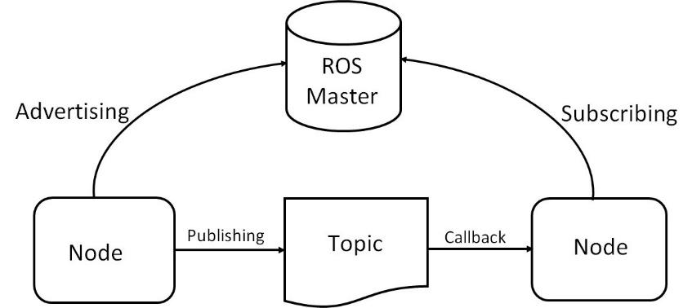

**Figure 3.4**. ROS Framework

Robotic operating system (ROS) is an open source framework developed for robotic purposes. It contains libraries and packages that are already built and ready to use for robots. ROS is a peer-to-peer network of processes that could run on multiple devices that are connected via network.

ROS center of communication is ROS Master. ROS master acts as a keeper of topics and services registration and information of ROS nodes. ROS nodes are the process of performing the computation. It publishes or subscribes ROS messages with other nodes via ROS topics. ROS message is data that has been simplified into a structure.

### Gazebo Simulation

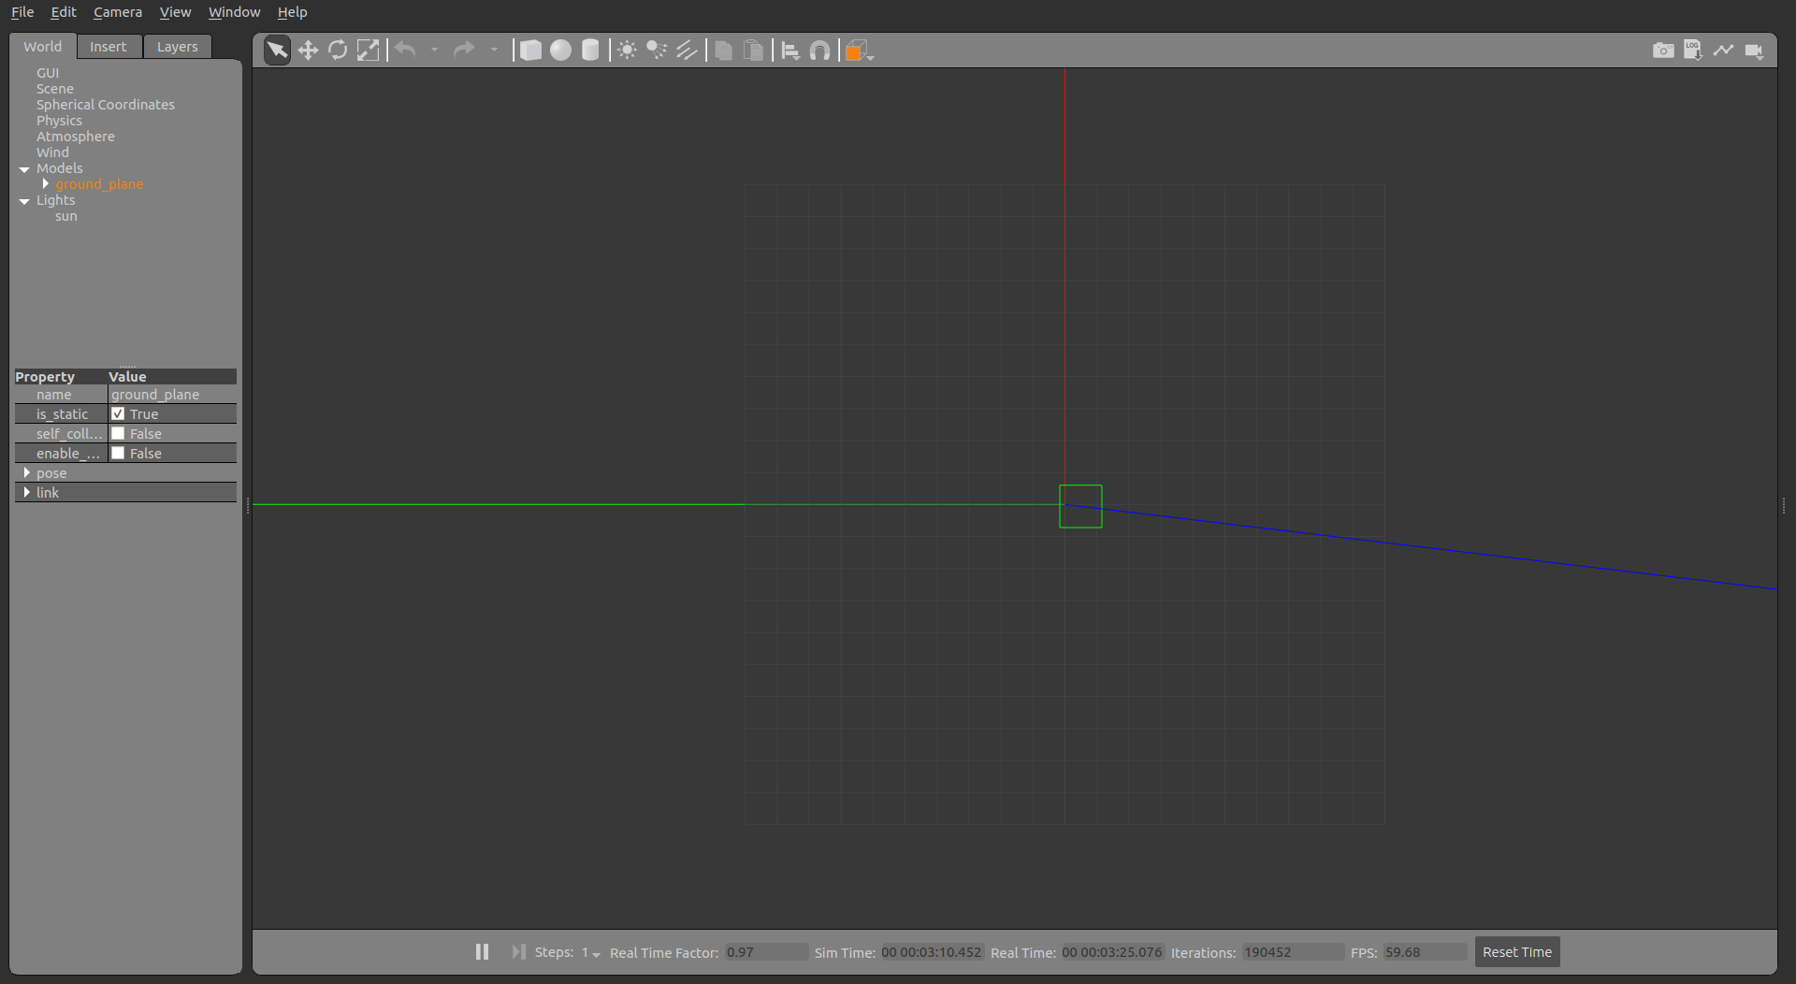

**Figure 3.5.** Gazebo Simulation Window

Gazebo is an open source physic 3D simulator that allow user to simulate and design the robot and the environment. Gazebo has the ability to simulate a highly accurate robot and sensor with the noise from the environment similarly to a game engine. In this thesis, we use Gazebo simulator a main software for our robot, sensor, and the environment simulation.

#### Gazebo Environment

In Gazebo environment, user can create their own robot accordingly to their design as well as the scenario of the surrounding environment for the experiment. In this thesis, we use Turtlebot3 Burger as a main simulate WMR that are equipped with Lidar, IMU, Odometry sensor. In addition to that, multiple scenarios will be used for SLAM implementation.

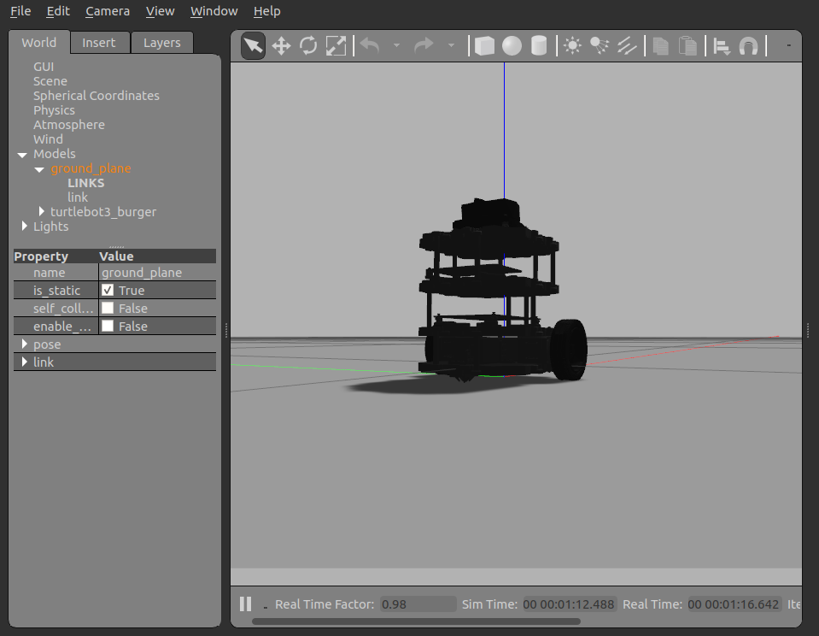

**Figure 3.6.** Turtlebot3 Burger Simulation Window

#### Subscribed / Published Topic

In Gazebo 3D Simulator, the WMR (Turtlebot3 Burger) subscribed to a controller keyboard teleoperation topic in order to move via the command from the user. Gazebo publish multiple ROS massage data such as robot state, link state, lidar, IMU and Odometry sensor, to the ROS topic from the simulator onto ROS master. By using the ROS message from the simulation, we can use it as a simulate data source for SLAM.

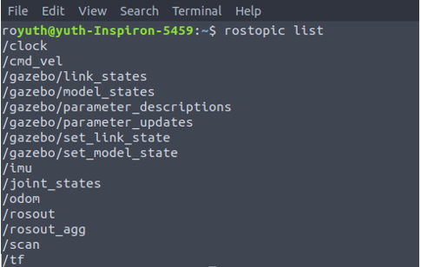

**Figure 3.7.** Gazebo Simulation ROS Topic

**Table 3.3.** Publish and Subscribe Simulation Topic

|  |  |  |  |  |
| --- | --- | --- | --- | --- |
| Topic | Message type | Frame ID | Description | Function |
| /joint_states | /sensor_msgs  /JointState |  | Status of joint in robot | Publish |
| /cmd_vel | /geometry_msgs  /Twist |  | Command WMR | Subscribe |
| /imu | /sensor_msgs  /Imu | /base_imu | Data from IMU | Publish |
| /odom | /nav_msgs  /Odometry | /odom | Data from Odometry | Publish |
| /scan | /sensor_msgs  /Laserscan | /base_laser | Data from lidar | Publish |
| /tf | /tf/tfMessage |  | Transform package | Publish |

### Coordinate Frame

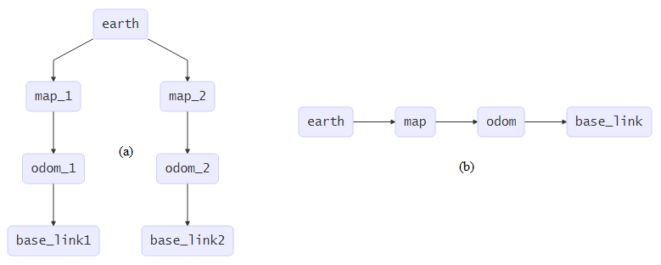

**Figure 3.8.** Coordinate Frame Relationship (a) Multiple Map; (b) Single Map

In SLAM, there are multiple coordinate frames that we need to utilize. Thus, we must define the base reference of those coordinates. According to ROS community guideline REP[105] (Wim Meeuseen, 2010) Coordinate Frames for Mobile Platform, we define

* **Base_link** or **Base_frame** as the coordinate that attached to mobile robot base. We define it as the point of reference of the WMR. Base_link is main link that WMR sensor is attached to.
* **Odom** as the world-fixed frame that is continuous without discrete jumps. This frame is drift over time that can accumulate the error in long term or in a large-scale map.
* **Map** as the world-fixed frame that is not continuous. In this frame the pose of WMR can be change with discrete jump.
* **Earth** as the coordinate the allow interaction between multiple maps.
* **Laser_frame** as the coordinate that assign to Lidar.

In the Gazebo Simulation, Lidar sensor is attached on top of the WMR. Thus, the when the WMR move, the coordinate of the Lidar move along with it. Map frame and Odom frame, is the static coordinate, while Base frame and Lidar coordinate move it Map frame and Odom frame.

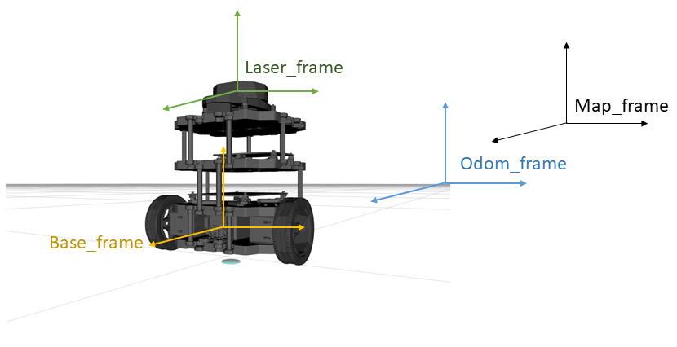

**Figure 3.9.** Simulation Coordinate Frame

### tf Tree

In any physical system there tend to be more than one coordinate frame. Thus, keeping track of all the coordinate frame is very important in our work.

tf the one of the most important ROS packages that enable user to track all coordinate frame as well as maintaining the relationship between each frame and publish it during the operation time, we can compute and transform one frame to another frame with this simple tf package. tf defined the robot with position and orientation. Position is expressed as vector and the orientation is expressed as quaternion vector form with .

In this thesis, tf package for static transform publisher has been used for transform coordinate system. In order to using this package, the following syntax has been used

**static_transform_publisher x y z yaw pitch roll frame_id child_frame_id period_in_ms**

where

static_transform_publisher is the name of tf package

x/y/z is offset [m]

yaw/pitch/roll is rotation about in [rad]

frame_id is the name of main frame

childframe_id is the name of the frame that will be transform to

period is how often to send a transform [ms]

### RVIZ

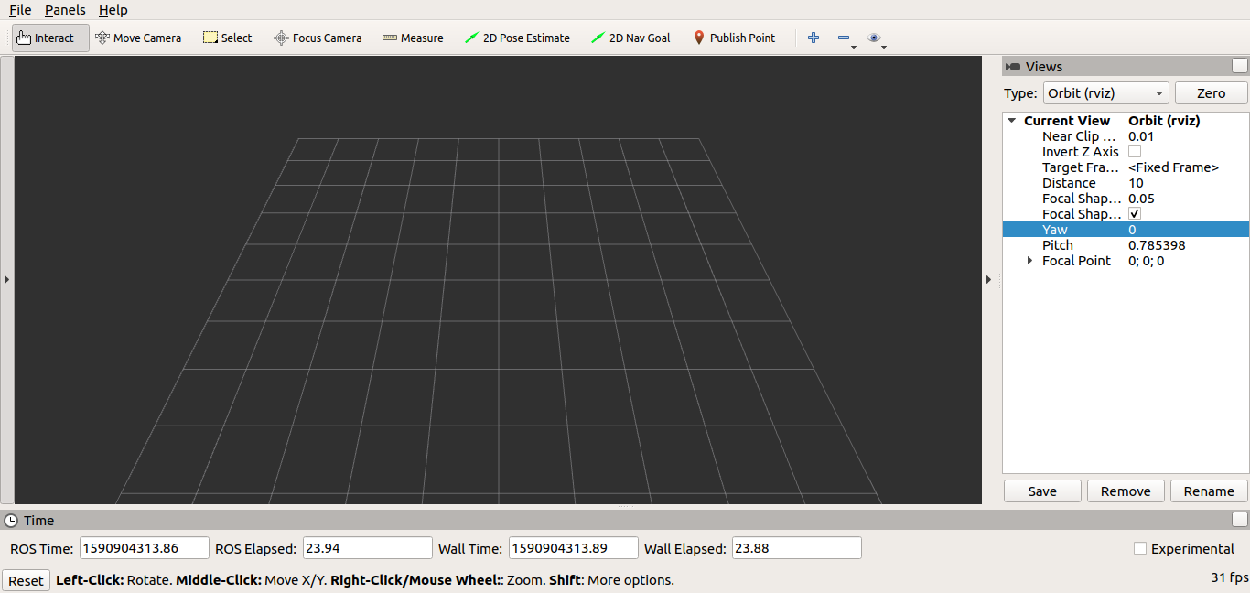

**Figure 3.10.** RVIZ Window

RVIZ is one of the 3D visualizations tools in ROS. RVIZ allows us to visualize and verify the incoming data from the ROS messages. In this thesis, RVIZ is used to visualize the Occupancy Grid Map, Robot Model, Sensor Data.

## SLAM Packages

There are numerous Open source SLAM packages developed by many robotic communities over the years. Most notable are Hector SLAM, Gmapping SLAM, and MATLAB SLAM which are used in this thesis for the implementation of SLAM.

### Hector SLAM Package (ROS)

Hector SLAM Package is one of many SLAM packages in ROS develop by Team Hector. Hector SLAM use hector_mapping ROS node for SLAM algorithm, provide the map of the environment. Scan Matching SLAM approach has been implemented in order to determine the displacement of WMR in 2D from previous and current consecutive scan. Hector SLAM can be use with or without the odometry data.(Stefan Kohlbrecher, 2012)

**Table 3.4.** Publish and Subscribe Hector SLAM Topic

|  |  |  |  |
| --- | --- | --- | --- |
| Topic | Message Type | Description | Function |
| /scan | /sensor_msgs  /LaserScan | Data from Lidar | Subscribe |
| /syscommand | /std_msgs  /String | User command Reset map | Subscribe |
| /map_metadata | /nav_msgs  /MapMetaData | Map Data | Publish |
| /map | /nav_msgs  /OccupancyGrid | Map Data | Publish |
| /slam_out_pose | /geometry_msgs  /PoseStamped | Robot pose estimated without covariance | Publish |
| /poseupdata | /geometry_msgs  /PoseWithCovarianceStamped | Robot pose estimated with Gaussian estimation of uncertainty | Publish |

**Table 3.5.** Hector SLAM Parameters

|  |  |
| --- | --- |
| Parameters Name | Description |
| base_frame | Main frame attached to robot for localization |
| map_frame | Frame of the map |
| odom_frame | Frame attached to Odometry |
| map_resolution | Size of grid cell in [m] |
| map_size | Number of cells per axis |
| map_start_x | Map origin on x axis |
| map_start_y | Map origin on y axis |
| map_update_distance_tresh | Threshold for performing map update in [m] |
| map_update_angle_tresh | Threshold for performing map update in [m] |
| map_pub_period | The map publish period in [s] |
| map_multi_res_levels | The number of map multi-resolution grid levels |
| updata_factor_free | The map update modifier for free cell |
| update_factor_occupied | The map update modifier for occupied cell |
| laser_min_dist | The minimum distance for laser scan endpoint to be used in system in [m] |
| laser_max_dist | The maximum distance for laser scan endpoint to be used in system in [m] |
| laser_z_min_value | The minimum height relative to the laser_frame |
| laser_z_max_value | The maximum height relative to the laser_frame |
| pub_map_odom_transform | Publish map_frame to odom_frame |
| output_timing | Output timing information for processing of every laser scan |
| scan_subscriber_queue_size | The queue size of the scan subscriber |
| pub_map_scanmatch_transform | Publish map_frame to scanmatcher_frame |
| tf_map_scanmatch_transform_  frame_name | Scanmatcher_frame name |

Hector SLAM Package Provide tf Transform /map_frame to /odom_frame that estimate the current robot’s pose in /map_frame. We have to provide our own tf transform from robot link (/base_link) to lidar link (/laser_frame) using tf static_transform_publisher ROS package.

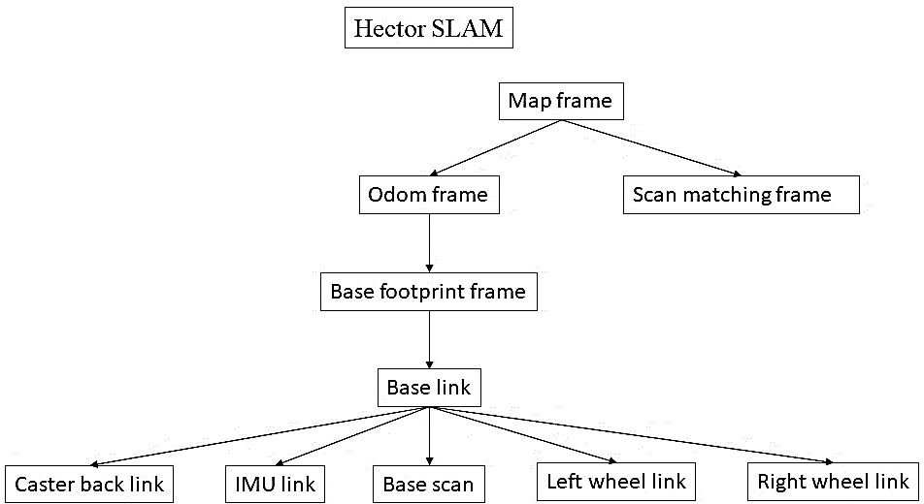

**Figure 3.11.** Hector SLAM tf frame

### Gmapping SLAM Package (ROS)

Gmapping SLAM is another SLAM ROS package which is developed by OpenSlam. Gmapping SLAM provide a laser-based SLAM by using slam_gmapping ROS node. Gmapping SLAM use Scan Matching algorithm for matching the income scans just like Hector SLAM. Using Gmapping SLAM required an odometry information in order to localize the robot pose. (Brian Gerkey, 2019)

**Table 3.6.** Publish and Subscribe Gmapping SLAM Topic

|  |  |  |  |
| --- | --- | --- | --- |
| Topic | Message Type | Description | Function |
| /scan | /sensor_msgs  /LaserScan | Data from Lidar | Subscribe |
| /tf | /tf/tfMessage | Frame transformation | Subscribe |
| /map_metadata | /nav_msgs  /MapMetaData | Map Data | Publish |
| /map | /nav_msgs  /OccupancyGrid | Map Data | Publish |
| /entropy | /std_msgs/Float64 | Entropy of the distribution estimation over robot’s pose (higher is more uncertain) | Publish |

**Table 3.7.** Gmapping SLAM Parameters

|  |  |
| --- | --- |
| Parameters Name | Description |
| inverted_laser | Laser CCW or CW |
| throttle_scans | Process 1 out of this many scan (Skip scan) |
| base_frame | Main frame attached to robot for localization |
| map_frame | Frame of the map |
| odom_frame | Frame attached to Odometry |
| map_update_interval | Duration between map update [s] |
| maxurange | Maximum usable range of the laser |
| sigma | The greedy endpoint matching |
| kernelsize | Look for a correspondence |
| lstep | The optimization step in translation |
| astep | The optimization step in rotation |
| interation | The number of iterations of the scan matcher |
| lsigma | The sigma of beam used for likelihood computation |
| ogain | Gain used while evaluating the likelihood for smoothing resampling effects |
| lskip | Number of beams to skip |
| minimumscore | Minimum score for considerating the outcome of the scan matching good |
| srr | Odom error in translation as a function of translation () |
| srt | Odom error in translation as a function of rotation () |
| str | Odom error in rotation as a function of translation () |
| stt | Odom error in rotation as a function of rotation () |
| linearupdate | Process a scan each time robot translates |
| angularupdate | Process a scan each time robot rotates |
| temporalupdate | Process a scan if the last scan processed is older that update time [s] |
| resamplethreshold | The Neff based resampling threshold |
| particles | Number of Particle in the filter |
| xmin | Initial map size in x axis [m] |
| xmax | Initial map size in x axis [m] |
| ymin | Initial map size in y axis [m] |
| ymax | Initial map size in y axis [m] |
| delta | Size of grid cell in [m] |
| llsamplerange | Translational sampling range for the likelihood |
| llsamplestep | Translational sampling step for the likelihood |
| lasamplerange | Angular sampling range for the likelihood |
| lasamplestep | Angular sampling step for the likelihood |
| transform_publish_period | Duration between transform publish [s] |
| occ_thresh | Threshold on gmapping’s occupancy value. |
| maxrange | Lidar maximum range |

Gmapping SLAM Package Provide tf Transform /map_frame to /odom_frame that estimate the current robot’s pose in /map_frame. We have to provide our own tf transform from lidar link (laser_frame) to robot link (base_link) and robot link (base_link) to odometry link (odom) using tf static_transform_publisher.

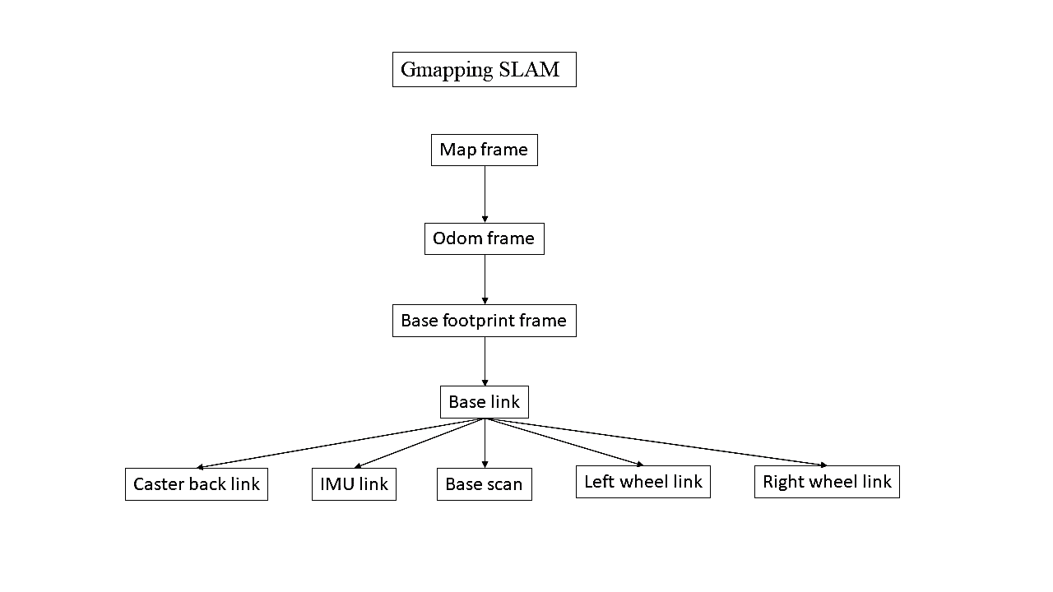

**Figure 3.12.** Gmapping SLAM tf frame

### MATLAB SLAM Package

Using MATLAB SLAM in Navigation Toolbox, we create an object that waiting for the series of incoming scan data from ROS Lidar subscribe function. We use **scansAndPoses** function to retrieve the collected scan and the estimated poses from the class the stored the scans information, then build the occupancy map using **buildMap** function.

**Table 3.8.** MATLAB SLAM Function

|  |  |  |  |
| --- | --- | --- | --- |
| Function | Parameters | | Description |
| Input | Output |
| lidarSLAM | mapResolution | Lidar Slam Class | Create an object to store lidarscan |
| maxLidarRange |
| lidarScan | Ranges | Lidar data | Create lidarscan object from lidar |
| Angles |
| addScan | lidarSLAM | Collected scans | Add scan to lidarSLAM object |
| lidarScan |
| scansAndPoses | lidarSLAM | scans | Extract scans and poses from lidarSLAM object |
| optimizedPoses |
| buildMap | Scans | OccupancyMap | Create an occupancy map |
| OptimizedPoses |
| mapResolution |
| maxLidarRange |

## Wheel Mobile Robot

Wheel Mobile Robot is one of the ground robots that move via the wheel that attached to robot’s body frame. There are different types of WMR that can be named after the number of wheels, drive mode, etc. WMR usually has been used as moving platform to move another object. In Robotic Community, WMR are equipped with sensors for further its functionality.

In this thesis, we use the Turtlebot3 Burger two wheels differential drive robot as a moving platform for our simulation.

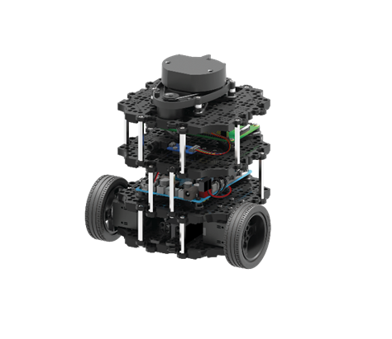

**Figure 3.13.** Turtlebot3 Burger

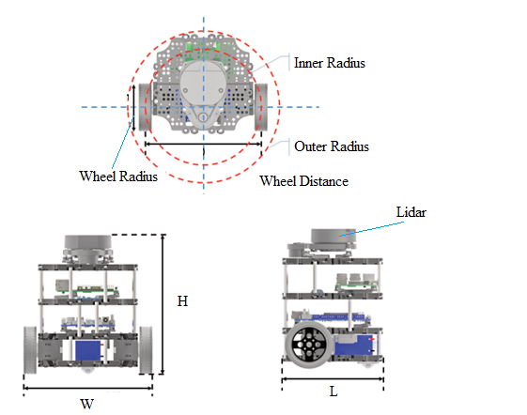

**Figure 3.14.** Turtlebot3 Burger Specification

**Table 3.9.** Hardware Specification

|  |  |  |
| --- | --- | --- |
| Parameters | Value | Unit |
| Wheel Radius | 66 | mm |
| Robot Width (W) | 178 | mm |
| Robot Length (L) | 138 | mm |
| Robot Height (H) | 192 | mm |
| Distance between wheel | 160 | mm |
| Robot Outer Radius | 105 | mm |
| Robot Inner Radius | 80 | mm |
| Maximum Translational velocity | 0.22 | mm/s |
| Maximum Rotational velocity | 2.84 | rad/s |

**Table 3.10.** WMR Sensor

|  |  |
| --- | --- |
| Sensor | Description |
| Lidar | 360 degrees scanner |
| IMU | Gyroscope 3 Axis |
| Accelerometer 3 Axis |
| Magnetometer 3 Axis |
| Odometer | 2 Wheels Odometer |

### Differential Drive WMR Kinematic Model

The WMR pose in 2D plane is defined in state vector as

|  |  |  |
| --- | --- | --- |
|  |  | **(Eq 3.28.)** |

The Global coordinate frame is represented as , and Robot frame is represented as . Using ROS coordinate system representation as Global Frame is /map_frame and WMR frame is /base_link. The relation between the global frame and robot frame is defined by a translation vector and rotation matrix about z axis

|  |  |  |
| --- | --- | --- |
|  |  | **(Eq 3.29.)** |

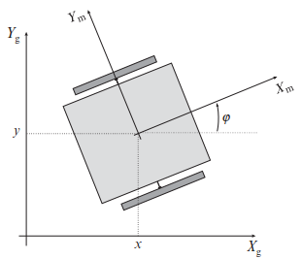

**Figure 3.15.** 2D Coordinate of Robot

For Two Wheels Differential drive WMR, its movement is depending on the rotation velocity of each wheel. These two wheels is independent to each other, meaning one can rotate faster or slower than the other. To make the rotation, each wheel could rotate in the same or different direction of each other at the different rotation rate. During the rotation of WMR in circular motion, there exist a common point that is intersect of 2-wheel axes called Instantaneous center of rotation (ICR).(Klančar et al., 2017)

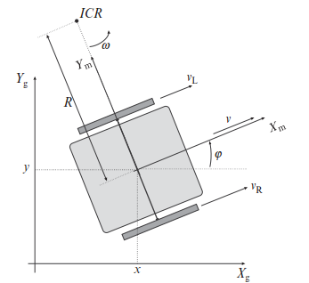

**Figure 3.16.** Differential Drive Kinematics

Let is the velocity of the right wheel

is the velocity of the left wheel

is the wheel radius

L is the distance between wheel

is the ICR

is the angular velocity in which both wheel rotate in the instance of time

is the WMR tangential velocity

is expressed as

|  |  |  |
| --- | --- | --- |
|  |  | **(Eq 3.30.)** |
|  |  | **(Eq 3.31.)** |

From **Eq 3.30.** and **Eq 3.31.**

|  |  |  |
| --- | --- | --- |
|  |  | **(Eq 3.32.)** |
|  |  | **(Eq 3.33.)** |

is expressed as

|  |  |  |
| --- | --- | --- |
|  |  | **(Eq 3.34.)** |

Each wheel tangential velocities are expressed as

|  |  |  |
| --- | --- | --- |
|  |  | **(Eq 3.35.)** |
|  |  | **(Eq 3.36.)** |

In Local coordinate frame, WMR kinematic

|  |  |  |
| --- | --- | --- |
|  |  | **(Eq 3.37.)** |

In Global coordinate frame, WMR kinematic

|  |  |  |
| --- | --- | --- |
|  |  | **(Eq 3.38.)** |

**Eq 3.38.** can be written in discrete Euler integration form with discrete time instant where is the sampling interval and

|  |  |  |
| --- | --- | --- |
|  |  | **(Eq 3.39.)** |

Forward Kinematics

Odometry of the robot is the pose of the robot at time that is obtained by integration of kinematic model. Odometry is explored more in 3.6.2.

|  |  |  |
| --- | --- | --- |
|  |  | **(Eq 3.40.)** |

**Case 1:** If and is assumed to be constant during sample time is expressed in **Eq 3.39.**

**Case 2:** If trapezoidal numerical integration is used, a better approximation is:

|  |  |  |
| --- | --- | --- |
|  |  | **(Eq 3.41.)** |

**Case 3:** If exact integration is applied

|  |  |  |
| --- | --- | --- |
|  |  | **(Eq 3.42.)** |

## Sensor

### Light Detection and Ranging Sensor (LIDAR)

Lidar is a remote sensing device that uses light pulses to detect the distance from an object and has been widely used for multi-purposes including navigation and mapping. Lidar usually contains a laser scanner and DC motor. The DC motor rotates the laser scanner in a 360 degrees circle in order to obtain a full 360 degrees of the environment. In this thesis, we use the simulation from 2D lidar that scans a 2D slice of a surrounding 3D environment.

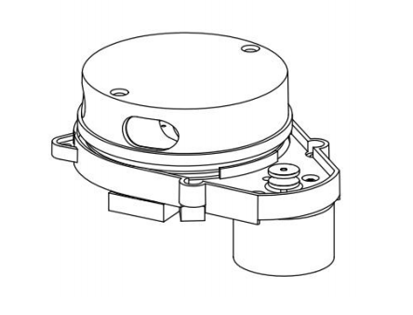

**Figure 3.17.** Lidar

#### Coordinate Frame

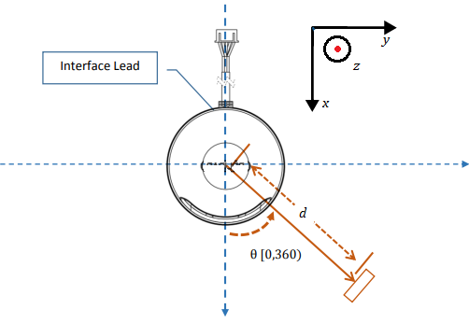

**Figure 3.18.** Lidar Coordinate System

Lidar Coordinate in 3D Cartesian coordinate system is where is pointing upward. But we only use the 2D Lidar simulation data, thus the Lidar Coordinate will be represented in 2D Cartesian coordinate system and the rotation angle of . The distance from the center of the laser scan to the object is . When the DC motor rotate, different angle and distance will be recorded, each and are correspond to each other.

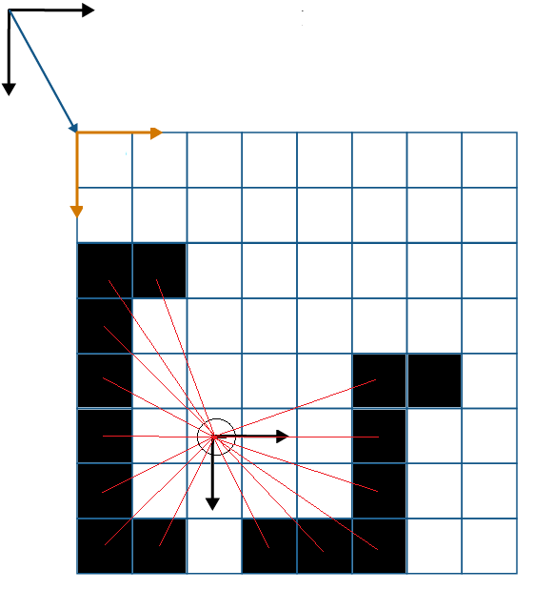

**Figure 3.19.** Lidar Laser Beam

#### Published ROS Topic

In ROS, Lidar node launch and publish on /scan topic with ROS message type sensor_msg/LaserScan.msg. The Lidar coordinate frame is /laser_frame.

**Table 3.11.** Lidar Properties

|  |  |  |
| --- | --- | --- |
| ROS message | Definition | Unit |
| header | Timestamp and frame_id |  |
| angle_min | Started angle of scan | rad |
| angle_max | End angle of scan | rad |
| angle_increment | Angular distance between scan to scan | rad |
| time_increment | Time between one full scan to one full scan | s |
| scan_time | Time between scan to scan | s |
| range_min | Minimum range | m |
| range_max | Maximum range | m |
| ranges | Range data in one full scan | m |
| intensities | Intensity data |  |

### Odometry

Odometry is the estimation of robot position and velocity within the environment using the calculation from the sensor data. Odometry can be computed from an odometry source such as wheel odometry, visual odometry (camera), or an IMU.

In Odometry 3D coordinate system the robot position is represented as and the orientation of the robot is represented as . As our robot is in 2D planar motion, thus we only interested in as written in state space form.

When using the ROS message, the odometry directly publishes with the position and the orientation of the robot from the simulated environment. The position is expressed as () and the orientation in quaternion form .

#### Published ROS Topic

In ROS, Odometry node launch and publish on /odom topic with ROS message type nav_msgs/Odometry.msg. The Odometry coordinate frame is /odom_frame.

**Table 3.12.** Odometry Properties

|  |  |
| --- | --- |
| ROS message | Definition |
| Header | Timestamp and frame_id |
| Child_frame_id |  |
| Geometry_msgs/PoseWithCovariance | Estimation of WMR Position in free space with uncertainty |
| Geometry_msgs/Pose | Contain the information of the position and orientation in quaternion form |
| Geometry_msgs/TwistWithCovariance | Estimation of WMR Velocity in free space with uncertainty |
| Geometry_msgs/Twist | Contain the information of velocity in linear and angular |

# SIMULATION AND DISCUSSION

## Simulation

In this thesis, we use Gazebo Simulation as our data source. Three of SLAM package, Hector SLAM, Gmapping SLAM and MATLAB SLAM, are carrying out. Using keyboard command to control robot movement in Gazebo simulation. During the operation time, the simulation output the sensor data and we subscribe to the data to use in each of SLAM packages. In ROS the Occupancy Grid will be viewed in RVIZ while in MATLAB it will be view in MATLAB Figure.

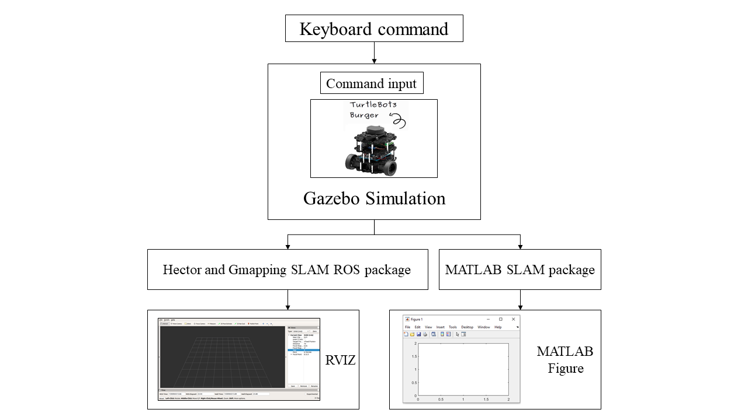

**Figure 4.1.** Simulation Flow

## Preparation Simulation

Before the simulation start, we have to configure the parameters of each package as well as our WMR parameters to meet our desire and as close as possible to the real-world condition. The file that required to modify are:

For Hector SLAM Package configuration main SLAM file Mapping_default.launch, we set odom_frame to /odom, base_frame to /base_footprint, scan_topic to /scan, map_frame to /map.

For Gmapping SLAM Package configuration main SLAM file gmapping_default.launch, we set odom_frame to /odom, base_frame to /base_footprint, map_frame to /map.

For MATLAB SLAM Package configuration script, we initiate MATLAB and ROS communication with rosinit function and set subscriber to ROS scan topic /scan.

## Data Collection and Analysis

**MATLAB SLAM**

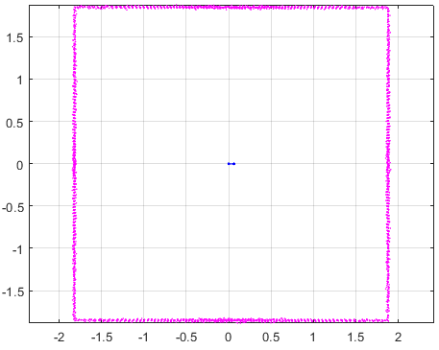

**Figure 4.2.** MATLAB Pose Graph SLAM gazebo_stage_1

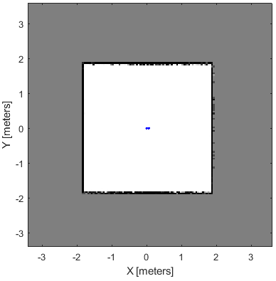

**Figure 4.3.** MATLAB Occupancy Map gazebo_stage_1

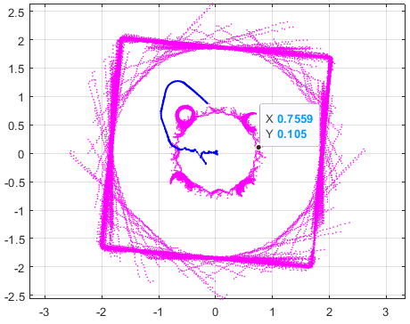

**Figure 4.4.** MATLAB Pose Graph SLAM gazebo_stage_2

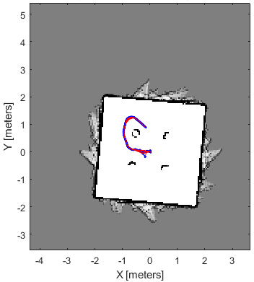

**Figure 4.5.** MATLAB Occupancy Map gazebo_stage_2

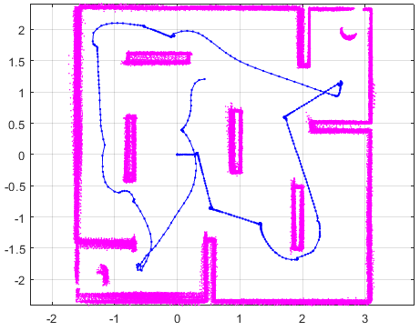

**Figure 4.6.** MATLAB Pose Graph SLAM gazebo_stage_3

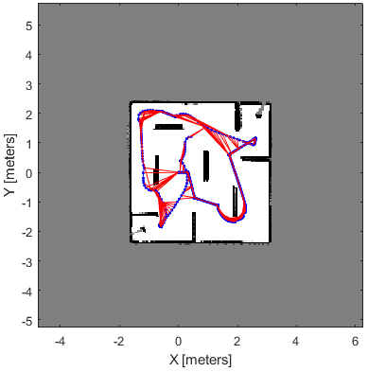

**Figure 4.7** MATLAB Occupancy Map gazebo_stage_3

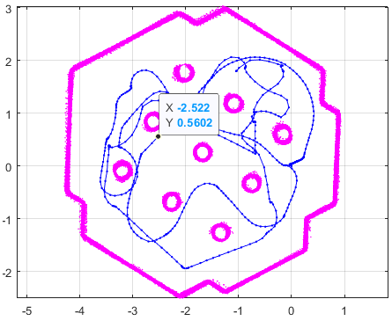

**Figure 4.8.** MATLAB Pose Graph SLAM gazebo_world

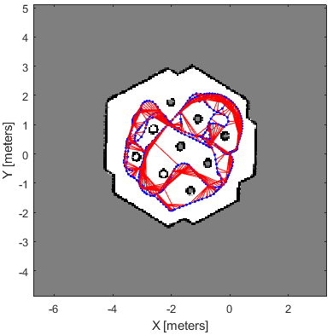

**Figure 4.9.** MATLAB Occupancy Map gazebo_world

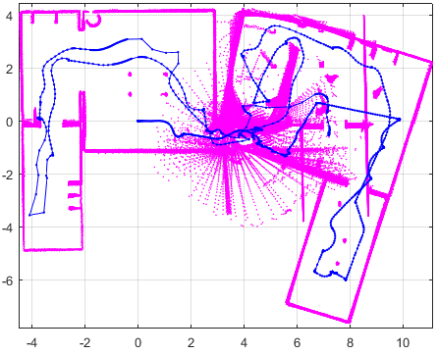

**Figure 4.10.** MATLAB Pose Graph SLAM gazebo_house

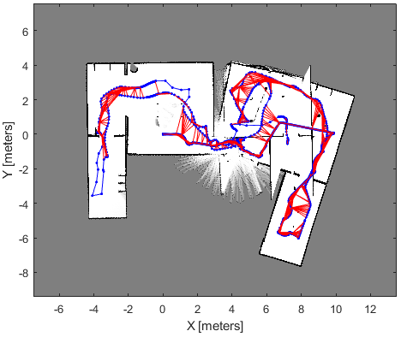

**Figure 4.11.** MATLAB Occupancy Map gazebo_house

**Hector SLAM and Gmapping SLAM Packages**

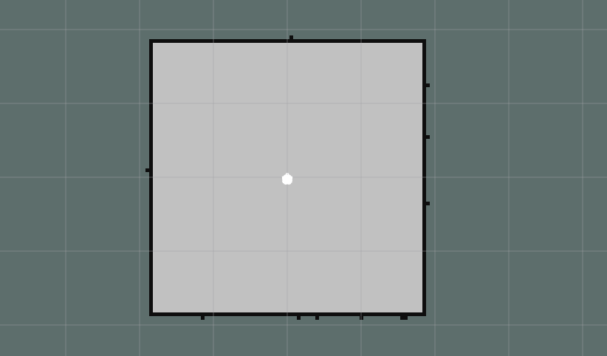

**Figure 4.12.** Gmapping SLAM Occupancy Map gazebo_stage_1

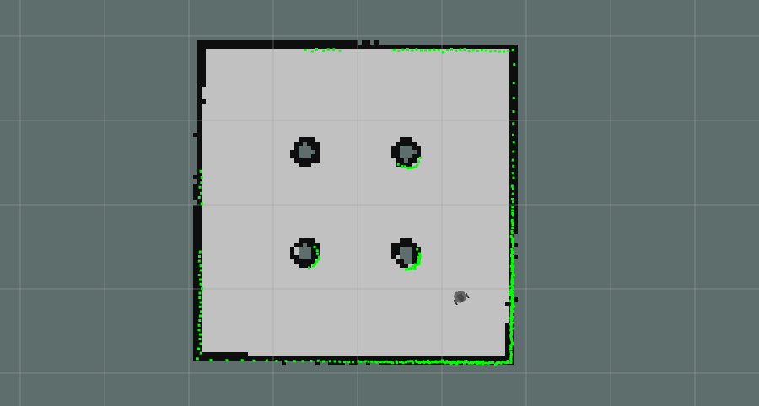

**Figure 4.13.** Gmapping SLAM Occupancy Map gazebo_stage_2

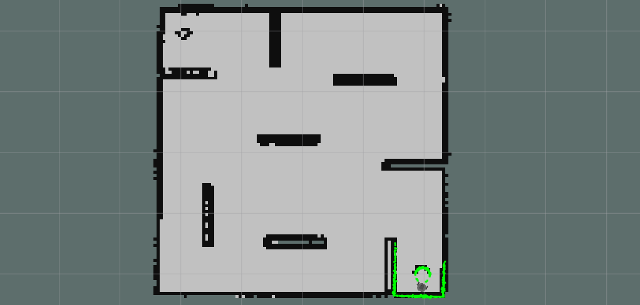

**Figure 4.14.** Gmapping SLAM Occupancy Map gazebo_stage_3

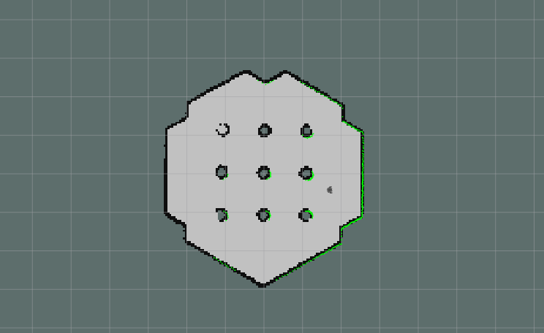

**Figure 4.15.** Gmapping SLAM Occupancy Map gazebo_world

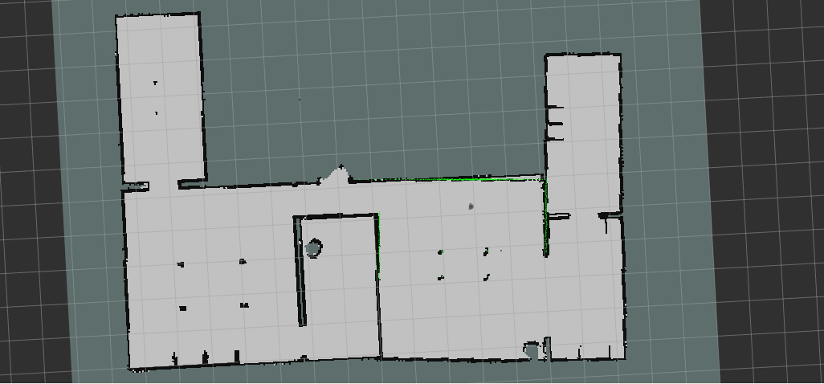

**Figure 4.16.** Gmapping SLAM Occupancy Map gazebo_house

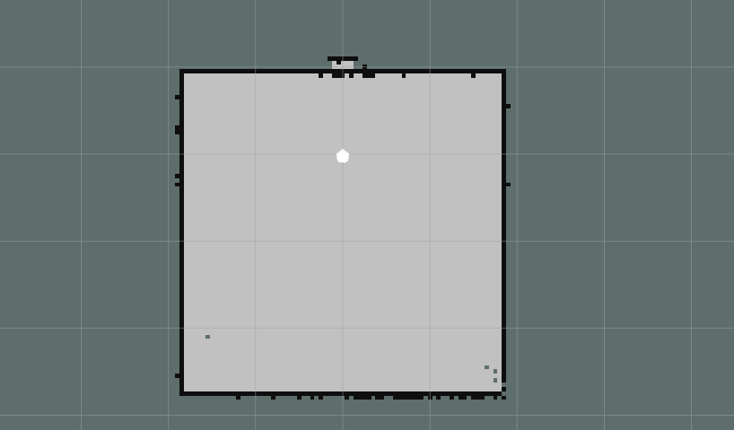

**Figure 4.17.** Hector SLAM Occupancy Map gazebo_stage_1

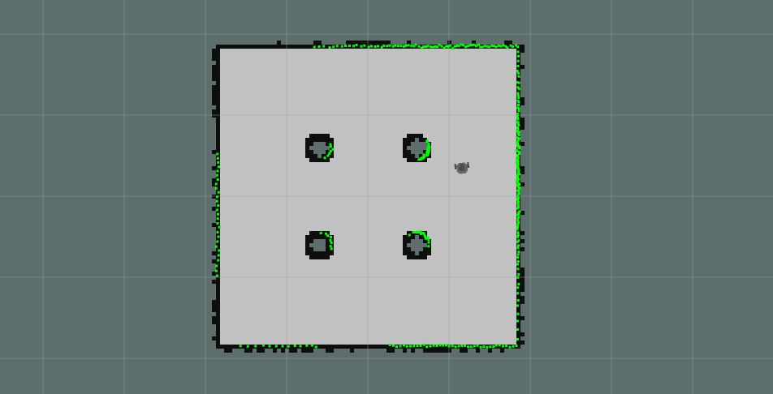

**Figure 4.18.** Hector SLAM Occupancy Map gazebo_stage_2

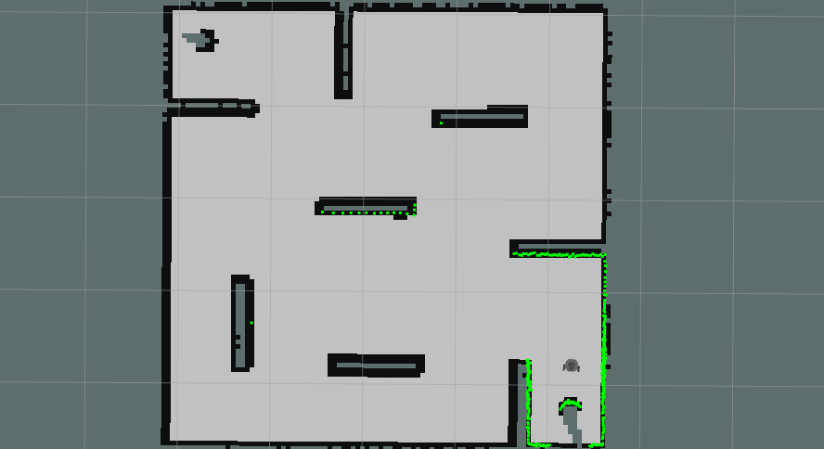

**Figure 4.19.** Hector SLAM Occupancy Map gazebo_stage_3

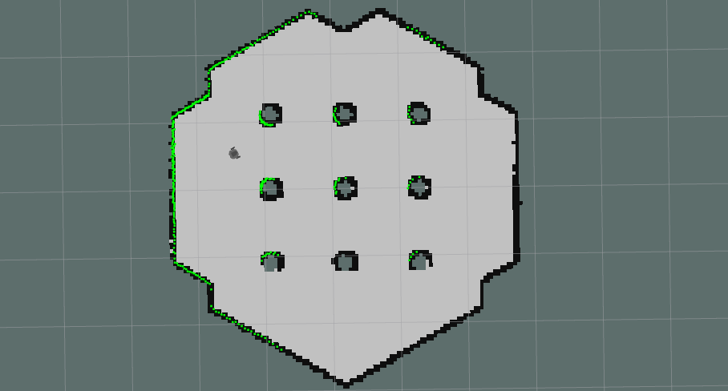

**Figure 4.20.** Hector SLAM Occupancy Map gazebo_world

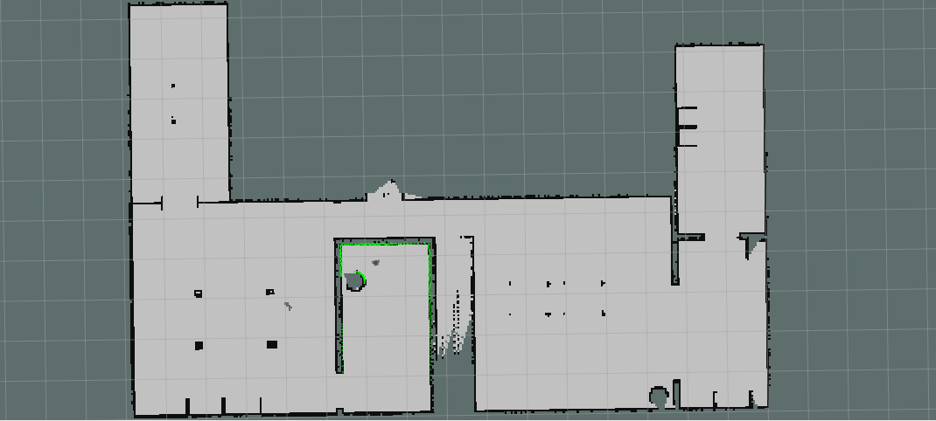

**Figure 4.21.** Hector SLAM Occupancy Map gazebo_house

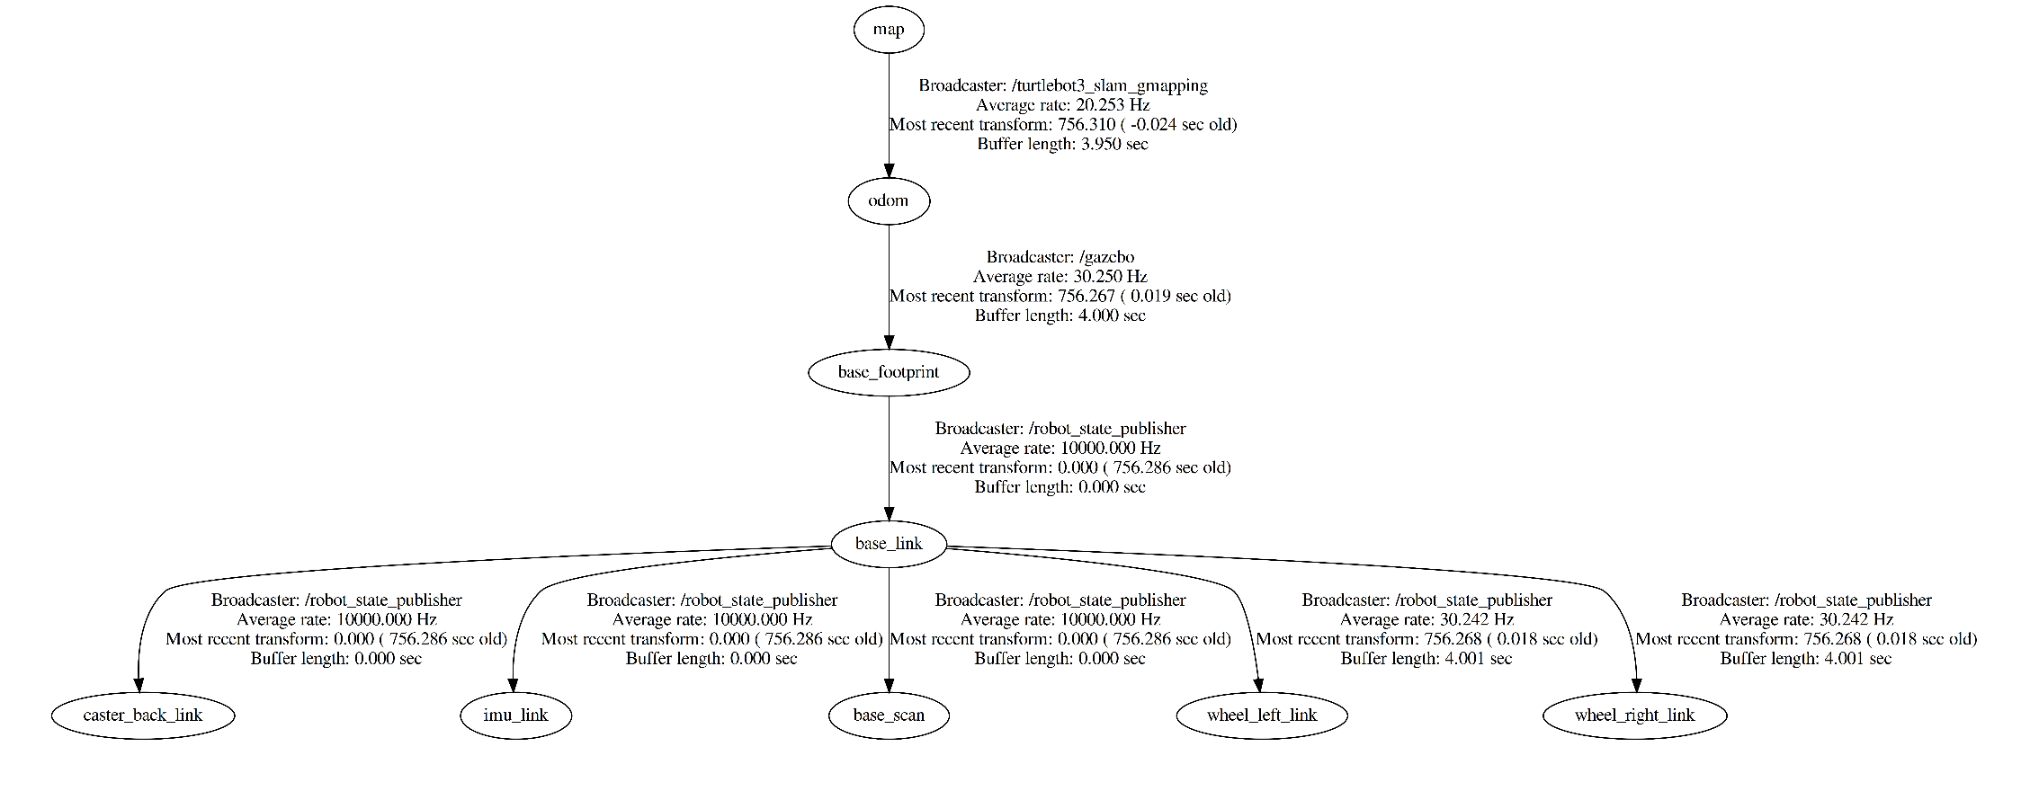

**Figure 4.22.** Gmapping SLAM tf Tree

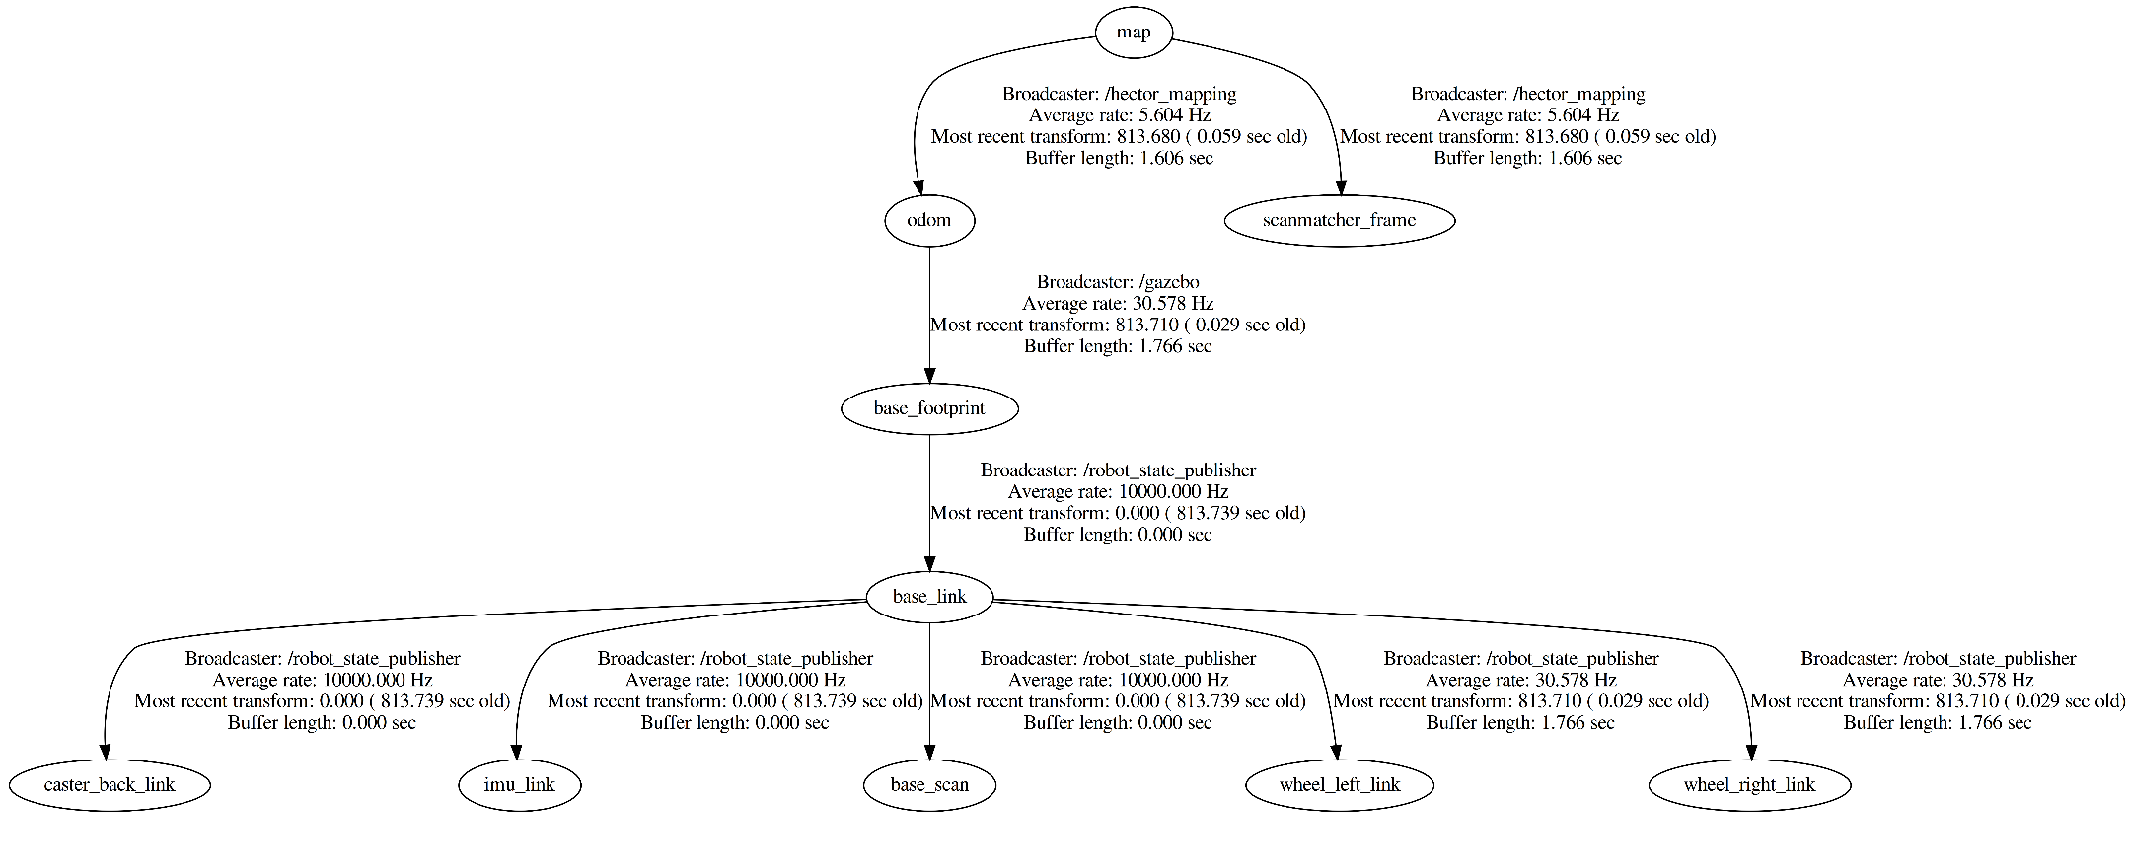

**Figure 4.23.** Hector SLAM tf Tree

# CONCLUSION AND RECOMMENDATION

## Conclusion

To conclude in this thesis, SLAM algorithm is presented. By using the simulation software, we are able to simulate the two-wheel differential drive WMR equipped with Lidar sensor and Odometry that publish data to implement SLAM. ROS is used as the main operation system to carry out the SLAM packages such as Hector SLAM, Gmapping SLAM, and MATLAB SLAM to create the Occupancy Grid Map of the simulated environment. While RVIZ and MATLAB are used for displaying the Occupancy Grid Map and sensor data. Comparing the obtained map from SLAM to the simulation environment, we can see the map represents the environment well in small scale map but induces error for a bigger scale one because of the accumulated error from odometry data. As the matter of fact, these maps can be used for robot navigation field.

## Recommendation Future Work

Using this SLAM approach with the data from the simulation give an acceptably good result. For the future work, this approach will be using in real world condition with the real data from the WMR and sensor. As we know, the incoming data from the real sensor will be corrupted by noise that effect on the obtained occupancy grid map. Thus, the sensor data filter can be used to correctly create an acceptable map for real use purpose such as path planning, autonomous driving and dynamic environment navigation with the help from other type of sensors.

# REFERENCE

Brian Gerkey. (2019). *gmapping - ROS Wiki*. http://wiki.ros.org/gmapping

Klančar, G., Zdešar, A., Blažič, S., & Škrjanc, I. (2017). Wheeled Mobile Robotics: From Fundamentals Towards Autonomous Systems. In *Wheeled Mobile Robotics: From Fundamentals Towards Autonomous Systems*.

Kohlbrecher, S., Stryk, O. Von, Meyer, J., & Klingauf, U. (2011). *[scan match in hector cartographer] A Flexible and Scalable SLAM System with Full 3D Motion Estimation*. 0–5.

Stefan Kohlbrecher. (2012). *hector_mapping - ROS Wiki*. http://wiki.ros.org/hector_mapping

Steven Waslander. (n.d.). *Lesson 2: Populating Occupancy Grids from LIDAR Scan Data (Part 2) - Module 2: Mapping for Planning | Coursera*. Retrieved June 28, 2020, from https://www.coursera.org/lecture/motion-planning-self-driving-cars/lesson-2-populating-occupancy-grids-from-lidar-scan-data-part-2-VcH67

The MathWorks, I. (2019). *Fuzzy Logic Toolbox TM User ’ s Guide R 2019 b*. https://www.mathworks.com/help/pdf_doc/fuzzy/fuzzy_ug.pdf

Thrun, S. (2002). Probabilistic robotics. *Communications of the ACM*, *45*(3), 52–57. https://doi.org/10.1145/504729.504754

Wim Meeuseen. (2010). *REP 105 -- Coordinate Frames for Mobile Platforms (ROS.org)*. https://www.ros.org/reps/rep-0105.html

# APPENDIX A

**MATLAB SLAM**

MATLAB SLAM script

%clear

close all

clc

%%

laser = rossubscriber('/scan'); %subscribe to /scan topic

maxLidarRange = 3.4;

mapResolution = 20;

slamAlg = lidarSLAM(mapResolution, maxLidarRange);

slamAlg.LoopClosureThreshold = 210;

slamAlg.LoopClosureSearchRadius = 8;

for i = 1:1500

laserdata = receive(laser,1);

Angles = double([0:0.0175:6.2832]');

Ranges = double(laserdata.Ranges);

lidarScanNew=lidarScan(Ranges,Angles);

[isScanAccepted, loopClosureInfo, optimizationInfo] = addScan(slamAlg, lidarScanNew);

if isScanAccepted

fprintf('Added scan %d \n', i);

end

end

%%

figure

show(slamAlg);

title({'Map of the Environment Pose Graph'});

%% occupancy grid map built

[scans, optimizedPoses] = scansAndPoses(slamAlg);

map = buildMap(scans, optimizedPoses, mapResolution, maxLidarRange);

figure;

show(map);

hold on

show(slamAlg.PoseGraph, 'IDs', 'off');

hold off

title('Occupancy Grid Map Built Using Lidar SLAM');

# APPENDIX B

**Hector SLAM**

Hector SLAM configuration file: hector_ws/src/hector_slam/hector_mapping/launch/mapping_default.launch

<?xml version="1.0"?>

<launch>

<arg name="tf_map_scanmatch_transform_frame_name" default="scanmatcher_frame"/>

<arg name="base_frame" default="base_footprint"/>

<arg name="odom_frame" default="odom"/>

<arg name="pub_map_odom_transform" default="true"/>

<arg name="scan_subscriber_queue_size" default="5"/>

<arg name="scan_topic" default="scan"/>

<arg name="map_size" default="2048"/>

<node pkg="hector_mapping" type="hector_mapping" name="hector_mapping" output="screen">

<!-- Frame names -->

<param name="map_frame" value="map" />

<param name="base_frame" value="$(arg base_frame)" />

<param name="odom_frame" value="$(arg odom_frame)" />

<!-- Tf use -->

<param name="use_tf_scan_transformation" value="true"/>

<param name="use_tf_pose_start_estimate" value="false"/>

<param name="pub_map_odom_transform" value="$(arg pub_map_odom_transform)"/>

<!-- Map size / start point -->

<param name="map_resolution" value="0.050"/>

<param name="map_size" value="$(arg map_size)"/>

<param name="map_start_x" value="0.5"/>

<param name="map_start_y" value="0.5" />

<param name="map_multi_res_levels" value="2" />

<!-- Map update parameters -->

<param name="update_factor_free" value="0.4"/>

<param name="update_factor_occupied" value="0.9" />

<param name="map_update_distance_thresh" value="0.4"/>

<param name="map_update_angle_thresh" value="0.06" />

<param name="laser_z_min_value" value = "-1.0" />

<param name="laser_z_max_value" value = "1.0" />

<!-- Advertising config -->

<param name="advertise_map_service" value="true"/>

<param name="scan_subscriber_queue_size" value="$(arg scan_subscriber_queue_size)"/>

<param name="scan_topic" value="$(arg scan_topic)"/>

<!-- Debug parameters -->

<!--

<param name="output_timing" value="false"/>

<param name="pub_drawings" value="true"/>

<param name="pub_debug_output" value="true"/>

-->

<param name="tf_map_scanmatch_transform_frame_name" value="$(arg tf_map_scanmatch_transform_frame_name)" />

</node>

<node pkg="tf" type="static_transform_publisher" name="map_nav_broadcaster" args="0 0 0 0 0 0 map odom 100"/>

</launch>

Hector SLAM launch file: hector_ws/src/hector_slam/hector_slam_launch/launch/tutorial.launch

<?xml version="1.0"?>

<launch>

<arg name="geotiff_map_file_path" default="$(find hector_geotiff)/maps"/>

<param name="/use_sim_time" value="true"/>

<node pkg="rviz" type="rviz" name="rviz"

args="-d $(find hector_slam_launch)/rviz_cfg/mapping_demo.rviz"/>

<include file="$(find hector_mapping)/launch/mapping_default.launch"/>

<include file="$(find hector_geotiff)/launch/geotiff_mapper.launch">

<arg name="trajectory_source_frame_name" value="scanmatcher_frame"/>

<arg name="map_file_path" value="$(arg geotiff_map_file_path)"/>

</include>

</launch>

# APPENDIX C

**Gmapping SLAM**

Gmapping SLAM configuration file: gmapping_ws/gmapping/launch/slam_gmapping_pr2.launch

<launch>

<!-- Arguments -->

<arg name="set_base_frame" default="base_footprint"/>

<arg name="set_odom_frame" default="odom"/>

<arg name="set_map_frame" default="map"/>

<!-- Gmapping -->

<node pkg="gmapping" type="slam_gmapping" name="turtlebot3_slam_gmapping" output="screen">

<param name="base_frame" value="$(arg set_base_frame)"/>

<param name="odom_frame" value="$(arg set_odom_frame)"/>

<param name="map_frame" value="$(arg set_map_frame)"/>

<param name="map_update_interval" value="2.0"/>

<param name="maxUrange" value="3.0"/>

<param name="sigma" value="0.05"/>

<param name="kernelSize" value="1"/>

<param name="lstep" value="0.05"/>

<param name="astep" value="0.05"/>

<param name="iterations" value="5"/>

<param name="lsigma" value="0.075"/>

<param name="ogain" value="3.0"/>

<param name="lskip" value="0"/>

<param name="minimumScore" value="50"/>

<param name="srr" value="0.1"/>

<param name="srt" value="0.2"/>

<param name="str" value="0.1"/>

<param name="stt" value="0.2"/>

<param name="linearUpdate" value="1.0"/>

<param name="angularUpdate" value="0.2"/>

<param name="temporalUpdate" value="0.5"/>

<param name="resampleThreshold" value="0.5"/>

<param name="particles" value="100"/>

<param name="xmin" value="-10.0"/>

<param name="ymin" value="-10.0"/>

<param name="xmax" value="10.0"/>

<param name="ymax" value="10.0"/>

<param name="delta" value="0.05"/>

<param name="llsamplerange" value="0.01"/>

<param name="llsamplestep" value="0.01"/>

<param name="lasamplerange" value="0.005"/>

<param name="lasamplestep" value="0.005"/>

</node>

</launch>

Gmapping SLAM launch file: gmapping_ws/src/tutorial.launch

<?xml version="1.0"?>

<launch>

<param name="use_sim_time" value="true" />

<node pkg="rviz" type="rviz" name="rviz"

args="-d $(find gmapping_launch)/rviz_cfg/mapping_test.rviz"/>

<node pkg="gmapping" type="slam_gmapping" name="gmapping_thing" output="screen" >

<param name="scan" value="scan" />

<param name="odom_frame" value="odom" />

<param name="base_frame" value="base_footprint" />

<param name="map_frame" value="map" />

</node>

</launch>

# APPENDIX D

**Interfacing ROS with MATLAB**

We are using ROS melodic on Nvidia Jetson Nano running Ubuntu 18.04 LTS (Bionic Beaver) with MATLAB 2019b running on Window10 OS. Nvidia Jetson Nano connect to Window 10 OS via Network Router

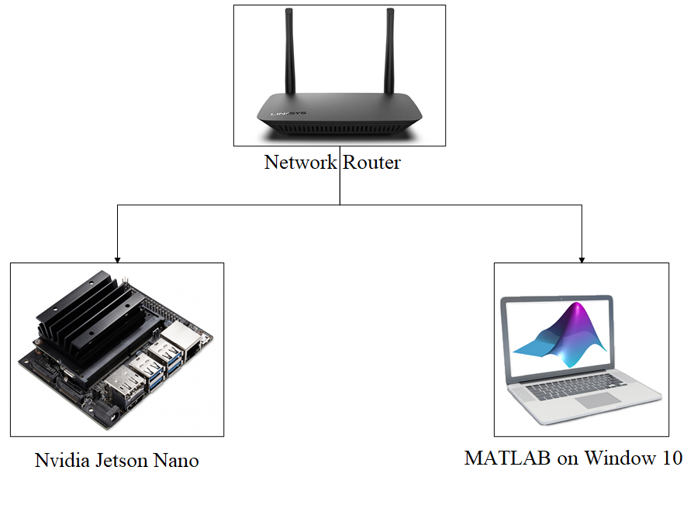

To establish connection between ROS on Ubuntu and ROS on MATLAB, we have to find IP address of both devices.

* For Window 10, open cmd window and enter ‘ipconfig’

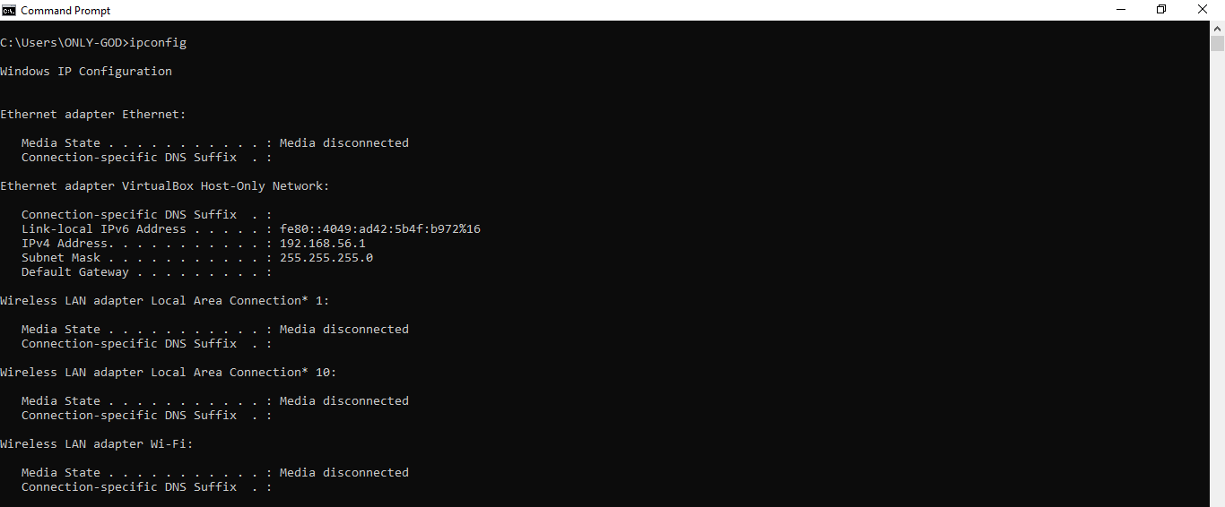

* For Ubuntu, open terminal and enter ‘ip addr’

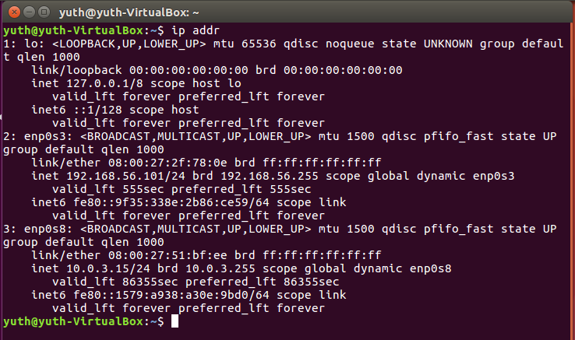

Testing Connection between device via pinging

* For Window 10, in cmd window, enter ‘ping <ubuntu ip address>’

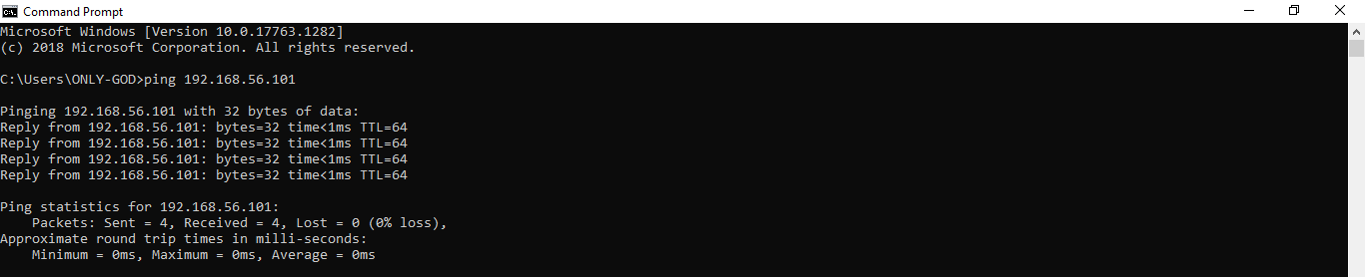

* For Ubuntu, in terminal, enter ‘ping <window ip address>’

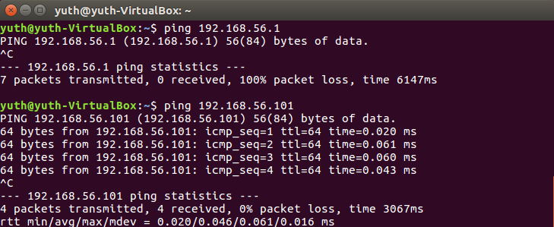

On Jetson Nano, Initiate command ‘roscore’ in ubuntu terminal to begin ROS Master

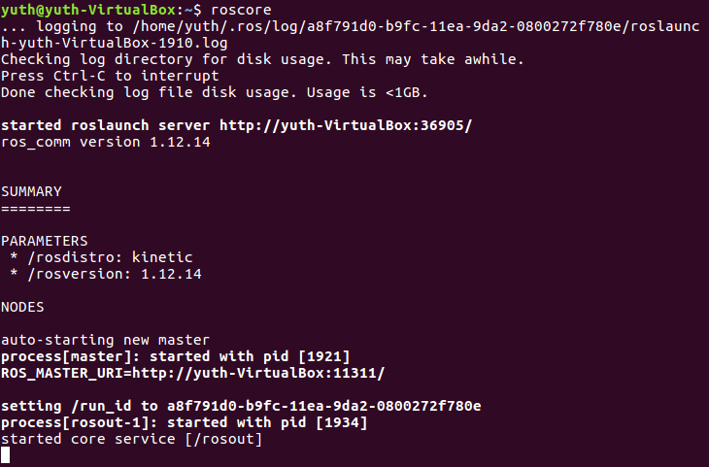

Establish connection from MATLAB to ROS machine via command ‘rosinit <ubuntu ip address>’

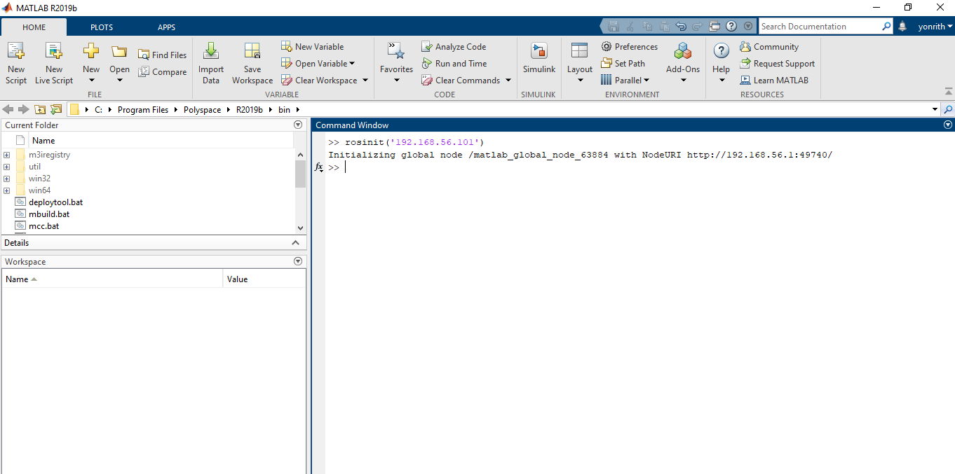

Testing the ROS connection by calling ROS topic in MATLAB via ‘rostopic list’

